About me  I am English<>Arabic translator with 15-year experience in professional communities. I am reliable and talented with proven ability to translate written documents from source to target language. A quick learner who can absorb new ideas and communicate clearly and effectively with people from all social and professional backgrounds. I am flexible in the ability to adapt to challenges whenever they arise. | 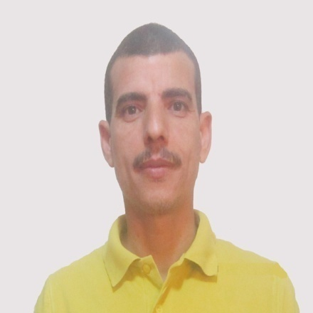  Sayid Omar  EN< >AR Senior Legal & Financial Translator & Reviewer
Skills  - Good communication skills.  - Good problem-solving skills.  - Good command of computer applications.  - Work effective even under pressure.  - Excellent team player.  - Ability to meet deadlines.  - Ability to prioritize work.  - Positive attitude.  - Attention to detail.  - Honest, trust worthy and reliable. | Education  - B.A. of Languages and Translation from the Section of Simultaneous Interpretation, the Faculty of Languages and Translation, Al-Azhar University in 2002 with very good grade.  - Currently, enrolled at the Faculty of Law, Cairo University.
Work History
Let me tell a bit more about my career and experience in Arabic-English translation field:
- 2001-2003: freelancer with translation firms in Egypt.
- 2003-2007: in-house translator with Al-Arabi Translation Office in Qassim, the KSA.
- 2008–2016: in-house senior legal and financial translator and reviewer with Marzouk Legal and Specialized Translation Office in Egypt with the following professional duties:
- Translate legal documents, financial statements, reports and presentations from English to Arabic and vice versa;
- Maintain formats for standard documents;
- Ensure jobs are completed on a quick turnover basis;
- Review and proofread documents;
- Revise junior translators' translations.
- 2016-Present (Back to Freelance): freelancer in general, legal and financial areas with highly prestigious and well-established translation firms in Egypt, UAE, KSA, USA and Qatar including:
- Diwan Arabia Translation Office, Egypt and Dubai.
- Top Notch Translation Office, Egypt.
- Mohammed Al-Khilaiwi Advocates and Legal Consultants, KSA.
- Qatar Translation Center, Qatar.
- GTS Translation Services, USA.
- Communication Legal Translation, UAE.
Contact
6 October, Giza
Egypt
Phone: (+2) 01228417185
01115501532
Email: wild_river_78@yahoo.com wild.river.1976@gmail.com

