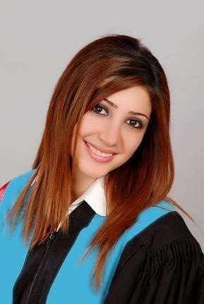

Personal Data
Name : Rouz Akram Yousef
Date of Birth: 29.1.1985 in Damascus
E-Mail: yousefrouz@gmail.com
Telefon number: 017685311588
Marital status: Single
Nationality: Syrian
Languages : Arabic (Mother tongue )
English ( fluent )
German (B2.2)

Education

2002-2009 Bachelor degree in medicine ( Jordan university for science and technology ) univeristy study in English

Work experience

06.2012- July 2014 Obst&Gynocological resident in Al Zahrawi hospital , Syria Damascus

Skills

Microsoft Office (Word, Excel & PowerPoint)

Rouz Yousef

