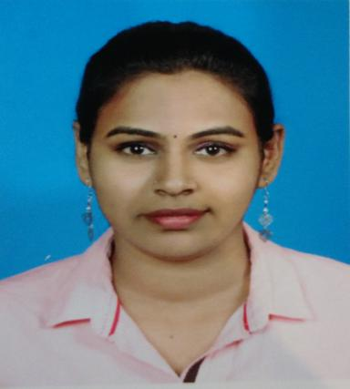
RATHI A/P MUNIANDY
Bachelor of Language and Linguistics
Graduated in 2012 at Malaya of University

PERSONAL DETAILS
Date of birth : 28th JANUARY 1989
Mobile : +6011-26179166
Nationality : MALAYSIAN
Gender : FEMALE
Religion : HINDU
Marital Status : SINGLE
Permanent Address : 189, KAMPUNG TUN SAMBANTHAN, 32400 AYER TAWAR, PERAK
Current Address : A-10-06, YOU RESIDENCES, JALAN PERSIARAN YOU CITY, CHERAS,
43200 SELANGOR DARUL EHSAN
Hp No : 011-26179166
E-mail : rathi890128@gmail.com / rathi_r20@yahoo.com

CAREER OBJECTIVE

To work as a bilingual translator for a reputed company and develop impressive creative copy and translations for clients.

ACADEMIC QUALIFICATIONS

Tertiary Level
2009 – 2012 Bachelor of Language and Linguistics
University of Malaya
CGPA: 3.92

Post-Secondary Level
2008 Sijil Tinggi Persekolahan Malaysia (STPM)
SMK Methodist ACS, Sitiawan
Pointer: 2.84

Secondary Level
2006 Sijil Pelajaran Malaysia (SPM)
SMK Methodist, Ayer Tawar
Result: 3A1, 4A2, 1B3, 2C5, 1C6

CURRICULAR INVOLVEMENT & RECOGNISED ACHIEVEMENTS

2010 Secretary, Student Service Corps
2010 Undergraduate Associates, University Malaya
2010 Participant, Tamil Debate Competition (UUM)
2010 Publicity Bureau, Amuthasurabi Food Stall
2010 Coordinator for Judges, R.Thandayutham Tamil Debate Competition
2011 Secretary, Cultural Night
2011 Committee Member, Tamil Linguistic and Literature Symposium
2011 Secretary, Student Outbound program to India

WORK EXPERIENCE

- Company Name : Goucera Marketing Sdn Bhd
- From/To : 10th September 2012- 31 December 2012
- Position Title : Temporary Clerk- (Marketing Service)
- Job description : Data entry, filing, process orders.

- Company Name : MERP Publication
- From/To : 2013 – till now
- Position Title : Part time Editor
- Job description : Edit and proof read novels, articles and publication materials

- Company Name : Thaimoli Sdn Bhd
- From/To : 2014 till April 2018
- Position Title : Journalist cum reporter
- Job description :
Attend press meet, prepare news articles for online portal and newspaper (THAIMOLI) based on press statements and audio recording - Edit and proof read articles, Interviewing people in a wide range of circumstances - Writing copy for publication on a tight deadline - Building contacts and sources for use in future stories - Fact-checking the information given to you by a source - Translate articles - Working closely with the news team, photographers and editor - Update social media account of the company

- Company Name : PHOENIX ENTERPRISE
- From/To : Jan 2018 till now
- Position Title : Journalist (Freelance)
- Job description :
Manage 2 online portals (Tamil Murasu & Malaysia Today) - Update news daily - Attend press conferences - Update social media account

- Company Name : PUTRA INTELEK INTERNATIONAL COLLEGE
- From/To : May 2018
- Position Title : Assistant Manager (Social Media Unit)
- Job description :
Update Social Media accounts, Edit and proofread promotional advertisement, Suggest advertisement channels

SKILLS

Computer Skills:

- Microsoft applications (Word, Excel, PowerPoint) – Advanced

Language Skills:
- Bahasa Malaysia (speaking, reading and writing)
- English (speaking, reading and writing)
- Tamil (speaking, reading and writing)
- Hindi (able to understand basics)

PERSONAL COMPETENCIES
- Ability to work in a fast-paced environment to set deadlines
- Excellent oral and written correspondence with an exceptional attention to detail
- Highly organized with a creative flair
- Enthusiastic self-starter who contribute well to the team
- Multitasking

EXPECTED SALARY
RM 3,000.00

REFERENCES
Tamil Selvan A/L Iyadurai
Editor, Tamil Murasu
012-2931655

Senthil Kumar A/L Nadarajah
Media Partner
017-3007390

