PERSONAL INFORMATION | Rami Salmo
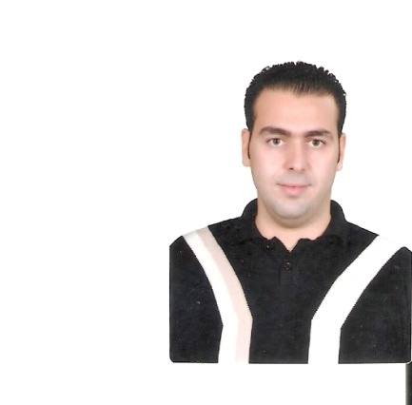 | Campos Novos 35-3H, Lugo, Spain
 | - +34632292309
 | rami.salmo22@gmail.com
 | www.facebook.com/rami.salmo
 | aboalroms22@hotmail.com
 | Sex male| Date of birth 22/2/1988 | Nationality Syrian

WORK EXPERIENCE
February 2018 – - English-Arabic call center employee at CCC Digital-Essen
September 2020

September 2015 - - practicing In Veterinary hospital for small animals in Spain
February 2017 - practicing In cow field major: milk and reproduction.

April 2012 -November2014  October 2014 - June 2015  September 2013 - September 2014 | Veterinarian assistant
With vet .(Nicola Salmo) my father

An English language Tutor

A volunteer in Syria trust for development In humanitarian support team,
A volunteer in MOBADROON network and A volunteer in the ((Disabled People And Their Friends)) in Latakia

EDUCATION AND TRAINING

September 2015 – February 2017: Master’s in Medicine and Veterinary Health Research – Santiago de Compostela university

January 2006 – September 2014: Bachelor’s in veterinary medicine – Albaath university
January 2008 – September 2014: Bachelor in English-Arabic Translation – Tishreen University (open learning system)
2005-2006: Certificate of general secondary study (scientific branch)

PERSONAL SKILLS

Mother tongue(s) | Arabic
Other language(s) | UNDERSTANDING |  | SPEAKING |  | WRITING
 | Listening | Reading | Spoken interaction | Spoken production
English  Spanish | C1  B2 | C2  B2 | C2  B2 | C1  B2 | C1  B2
Levels: A1/2: Basic user - B1/2: Independent user - C1/2 Proficient user
Common European Framework of Reference for Languages

Job related skills | - A good command in English language.  - A special way to teach English for non-native people.  - A light accent that can help the students to understand me perfectly while I am speaking English.

Job-related skills | - A veterinarian assistant for 3 years  - An English tutor for 2 years  - Laboratory work, ELISA developer.

