RESUME
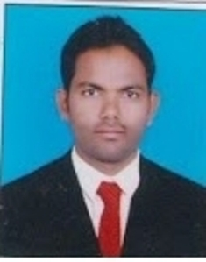
RAMESH PALLE E-mail: ramspalle5450@gmail.com
Mob: 9701685450
Objective:
Intend to build a career with leading corporate of hi-tech environment with committed and dedicated people, which will help me to explore myself fully and realize my potential. Willing to work in a challenge & creative environment to improve my self –esteem.
Education:
COURSE | INSTITUTE | PERCENTAGE
PG [M.Sc Engg.Physics & Instrumentation] | UPGC Godavarikhani, Karimnagar | 70.45
B.Ed [Physical Sciences] | L.B.College,Warangal | 69.07
DEGREE [B.Sc (MPC)] | CKM College,Warangal | 64.27
INTERMEDIATE [MPC] | Vidyanikethan Jr College,Warangal | 59
SSC | ZPSS Narayanagiri,Warangal | 78.16

Computer Skills:
PGDCA, MS Office,
Introduction to Translation NTM

Hobbies:
Reading Books
Watching News
Browsing, Translation different types of things

Strengths:
Hard work
Interested in learning new technologies
Honest, Committed and dedicated towards
Work Posses excellent analytical

Exeperience: 2 years in college and 2 years in schools, Translation knowledge texts since 2014 from English to Telugu.

Personal Profile:

Name : RAMESH PALLE
Father Name : BALARAJU
Date of Birth : 20-06-1983
Sex : Male
Marital status : Married
Languages known : Telugu, Hindi &English
Nationality : Indian
Permanent Address : H No 4-64
Post Mupparam
Mdl Dharmasagar
Dist Warangal
Andhra Pradesh 506142

Declaration:

I hereby declare that the information furnished above is true to the best of my knowledge.

Date:04/04/2015 (RAMESH PALLE)
Place: Warangal

