CURRICULUM VITAE
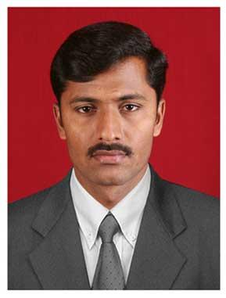
E.RAMESH
C/O K.T.Jayanna,
# 93/1, M.M. Road,
Byatarayanapura, Mysore Road,
Bengaluru-560026
Karnataka, INDIA.
Contact: 9731373752
E-mail: ramesh.nmhalli@gmail.com

PROFESSIONAL EXPERIENCE:

COMPANY | DESIGNATION | DURATION
Vijayakarnataka  (The Times Group) | Senior Copy Editor | 2 Yrs (March, 12-till date)
Samaya News | Bulletin Producer | 2 and half years (Dec, 09 – Feb, 12)
Wikipedia | Senior Translator | 4 months (Aug, 09 – Nov, 09)
Aegis BPO (ESSAR group) | Language Trainer | 1 yr (Jul, 08 – Jul, 09)
Kannadanadi (Weekly) | Senior Reporter | 6 months (Jan, 08 – Jun, 08)
TV9 | Reporter | 1yr 4 months (Jun, 06 – Sep, 08)
Aishvarya Kannada Naadu  (Agricultural Weekly) | Reporter & Sub Editor | 6 months (Oct, 05 – Mar, 05)
*Presently working with Vijayakarnataka as a Sr. Copy Editor

PROFESSIONAL SKILLS:
- Strong hold in Kannada Language
- Very good at English to Kannada Translation
- Speed typing in English & Kannada
- Adventurous Personality
- Much Interested in Media/teaching/translation

ACADEMIC QUALIFICATIONS:

Qualification | University | Percentage | Year
PhD* | Kannada University-Hampi | - | Registered in 2010
M.Phil. (Literature) | Kannada University-Hampi | 66.00% | 2007
M.A.(Kannada) | Bangalore University | 73.00% | 2004-05
B.A. | Bangalore University | 56.00% | 2001-03
* Research is in progress since 2010 on the subject of ‘Post colonial Kannada intellectual Discourse’

COMPUTER SKILLS:

Diploma In Office Automation | MS-Word, MS-Power Point, MS-Excel, FoxPro
Web Designing | HTML, FrontPage
Internet | All format of Internet

PERSONAL PROFILE:
- Mother's Name : Siddagangamma
- Father's Name : Eranna
- Date of Birth : June 29, 1982
- Age : 31 Years
- Sex : Male
- Marital Status : Single
- Languages Known : Kannada, English

HOBBIES:
- Reading Books
- Watching News Channels
- Watching documentaries on National Geographic, Discovery, History channel…..
- Listening music and so on

INTERESTS:
- Literature and Research
- Forest and Adventures
- Photography and documentaries
- Science and Technology

REFERENCE:
Dr. Byramangala Ramegowda
Associate Professor,
Govt First Grade College,
Rajajinagar, Bangalore.

DECLARATION:

I do hereby declare that all the above statements are true to the best of my knowledge and belief.

Date: 20, February 2014
Place: Bangalore (E.RAMESH)

