CURRICULAM

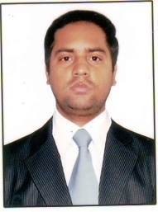

PRAHLAD KUMAR
I-27, BASHEER MEN’S HOSTEL Contact No: +91-9676648893
EFL-UNIVERSITY E-mail: phonieflu@gmail.com
HYDERABAD – 500007

OBJECTIVE

To be a part of a dedicated work of an organization and achieve the target laid down by the company.
Using the best of my knowledge and available resources where I can use my language and communication
Skill.

.ACADEMIC QUALIFICATIONS

- B.A. (Hons.) in SPANISH from EFL- University, Hyderabad. Now doing MA in Spanish

- 12th, from BSEB, Patna in 2007

- 10th , from BSEB Patna in 2005

EXPERIENCE
One year teaching experience (Spanish)
Four month job experience of dealing with Spanish native.
I have been working as a freelance translator.

COMPUTER AND SOFTWARE SKILLS
- Basic Knowledge of Computer (MS Office) and Internet

HOBBIES
- Reading books, playing chess….

PERSONAL DETAILS

Father’s Name : SURESH SINGH
Date of Birth : 04thAPRIL, 1989
Sex : Male
Marital status : Single
Nationality : Indian

STRENGTHS
- Fast learner
- Positive attitude
- Adaptability(language and socio-cultural )
- Good communication & presentational skills.
- I am an enthusiastic and versatile person keen to use my language skills in the communication field.

DECLARATION
I hereby declare that the information furnished above is true to the best of my knowledge.

Place: - HYDERABAD

Date: - 14.12.2013 PRAHLAD KUMAR

