Prabhu Jhingran
Hindi ↔ English Translator
Media Consultant / Content Writer / Editor / PR / Cine Historian
Lucknow, Uttar Pradesh
mediamantra2000@gmail.com , Mob. 9415408419
Website : avadhupdate.com
WORK EXPERIENCE
HINDI / ENGLISH WRITING
Prabhu Jhingran (Born January, 1952) is an accomplished broadcaster] Journalist, Writer and Media & PR Consultant. In a career spanning over 35 years, he started as special correspondent with Aaj, a renowed Hindi daily and later worked in All India Radio & Doordarshan, in different capacities. He was chief PRO with Allahabad Bank for more than 7 years. He was also Director of Educational Television (SIET, MHRD, Govt. of India) for several years.
His Last Govt. assignment was Dy. Dir. Gen. DDK Bhopal. Under his leadership the Lucknow Doordarshan Kendra was adjudged the Best Centre in 2003 for over all performance while SIET, UP was declared the best Site of the Country in the year 2000, by the Ministry MHRD. A versatile personality, Prabhu has written research papers, articles, columns, features & reports on a number of subjects for newspapers an periodicals. He has also edited many journals for a long time. He has also produced many TV features an Documentaries and is known for the tele-serial "Teesri Aankh" - the first of its kind in the country based on real life investigation. He lectures in Media theory, TV production, PR/Advertising and is a guest faculty for various Media Institutes.
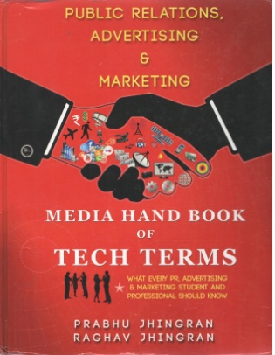
Public Relations, Advertising & Marketing : Media Hand Book of Tech Terms is his Sixth and the latest book which follows Doordarshan (1996), Television Ki Duniya (2001) which was given Baburao Vishnu Paradkar Award as the best book of the year by UP Hindi Sansthan in the Media category and Illustrated Media Glossary (2006) was awarded Bhartendu Award by Ministry of I & B, Govt. of India. His last book "The Practical Illustrated Media Hand Book - "Film & Cinematography" is a major reference book for many Institutes in India and abroad. He is doing 2 books on Internet & Print Media. Till now he was working as Media Consultant with National Institute of Technical Teachers Training and Research (MHRD) Bhopal) He has post graduation in Mass Communication and Media Production with Gold Medal as well as M.A. in Hindi Literature and 2 years Diploma in Painting from B.H.U.. He is also member of Global Internet Society. He is available for Part time/Full time Consultancy in any Media Related Project / Assignment / Job.
He can be contacted at: - mediamantra2000@gmail.com.
EDUCATION
Post Graduate- Hindi and Mass Com in Media (With Gold Medal), Television, Film, Print Media from Banaras Hindu University (BHU).
SKILLS
Creative Writing, Translator, Editor
Experience
11 Years Experience of Translation & Editing from English to Hindi and Hindi to English for Various Agencies and Organizations. Writing Experience for News Papers and Periodicals.

