Europass
Curriculum Vitae
Personal information |  | 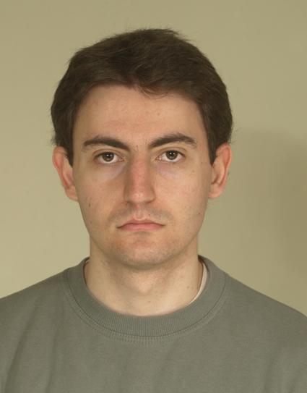
First name Surname |  | Plamen Velyov
Address |  | Dupnitsa(2600) Sveti Ivan Rilski 215
Telephone |  | Mobile: |  |  |  |  | 0885139661
E-mail |  | p_velyov@abv.bg
Nationality |  | Bulgarian
Date of birth |  | 14.05.1988
Gender |  | Male
Desired employment / Occupational field |  | Translation / Interpreting
Work experience

Dates  Occupation or position held  Main activities and responsibilities  Name and address of employer  Type of business or sector |  | March 2012 - present  Translator  Translation of variety of legal documents; translation of technical text  Lega Trans  Translation
Dates |  | 09.2011 – 12.2011
Occupation or position held |  | Translator
Main activities and responsibilities |  | Dubbing translation for several television shows;  Dubbing translation for a National Geographic documentary
Name and address of employer |  | Freelance
Type of business or sector |  | Translation
Dates |  | 10.2006 – 11.2006
Occupation or position held |  | System administrator
Main activities and responsibilities |  | Maintenance of users’ internet connection
Name and address of employer |  | Cable Sat Zapad, Dupnitsa
Type of business or sector |  | IT
Dates |  | 2005 - 2007
Occupation or position held |  | Website administrator
Main activities and responsibilities |  | Translation of articles and news feed. Maintenance of users’ profiles.
Dates |  | October 2003, June 2004
Occupation or position held |  | Writer
Main activities and responsibilities |  | Writing of articles concerning computer games and related topics for two different publications
Education and training  Dates  Type of qualification awarded  Principal subjects/occupational skills covered  Name and type of organisation providing education and training  Dates  Principal subjects/occupational skills covered  Name and type of organisation providing education and training |  | 2007-2012  Bachelor of Arts  English Studies  New Bulgarian University  October 2012 - present  Translation and interpreting  New Bulgarian University
Dates |  | 2001 – 2006
Title of qualification awarded |  | Middle special
Principal subjects/occupational skills covered |  | Electronics with intensive study of English
Name and type of organisation providing education and training |  | PG S.P.Koroliov
Certificates |  | Acquired an IELTS certificate
Personal skills and competences
Mother tongue(s) |  | Bulgarian
Other language(s)
Self-assessment |  |  | Understanding |  |  |  |  | Speaking |  |  |  |  | Writing
European level (*) |  |  | Listening |  | Reading |  |  | Spoken interaction |  | Spoken production
English |  |  | C2 | Proficient | C2 | Proficient |  | C2 | Proficient | C2 |  | Proficient | C2 | Proficient
Italian |  |  | B2 | Advanced | B2 | Advanced |  | B2 | Advanced | B2 |  | Advanced | B2 | Advanced
Spanish |  |  | A2 | Basic | A2 | Basic |  | A2 | Basic | A2 |  | Basic | A2 | Basic
Social skills and competences |  | Sociable, quick comprehension and adaptation.
Organisational skills and competences |  | Good organisational skills. Experienced in organising and administrating official events.
Technical skills and competences |  | Sufficient knowledge of computer hardware. Basic knowledge of electronics.
Computer skills and competences |  | MSOffice, Prompter Translator, Bultra, HandAlign.
Artistic skills and competences |  | Developed creativity. Experienced in writing. Appreciative of a variety of art forms.

