Olena Kulikova (translator En-Ru, En-Ukr)
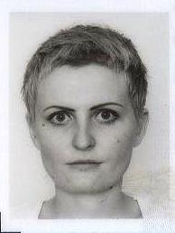
Email: lenakulikova2016@gmail.com
Skype: diamondDskype
Mob: +380951221562
Job Experience
Sept. 2016 – Sept. 2017 TM-Town(Pro-Z), Upwork, TranslationDirectory, 4writers.net platforms, freelance translator.
My latest projects include business presentation (Ru-Eng, fish farming, 500 words), corporate event scenario (Ru-Eng, coffee legends, 1500 words), and some college assignments written in English.
Apr. 2014 – June 2016 Golos.ua (news agency), news-line editor.
Among the other responsibilities, I translated news from Reuters, BBC, and The Guardian. I was also rewriting and proofreading news in Russian, visiting press-conferences, cooperating with the team of correspondents.
Nov. 2012 – Apr. 2013 KyivWeekly (newspaper), freelance journalist.
Besides working as a journalist, I tried to use my language skills as well, and have written several articles in English.
http://kyivweekly.com.ua/style/city/2013/01/18/114234.html, http://kyivweekly.com.ua/style/city/2013/02/22/132634.html.
Education
Sept. 2005 – June 2010 Taras Shevchenko National University of Kyiv, Institute of Journalism
Personal information
I am a self-motivated person, who always tries to find something relevant and new in the huge arrays of information. I enjoy working on projects by myself and as a team player. I am open to use CAT tools, Skype, and Google Chrome extensions in my job; have a PC with strong Internet connection. My working hours are 10:00-20:00 Mon-Fri. My rate per word is 0,01-0,02 USD.

