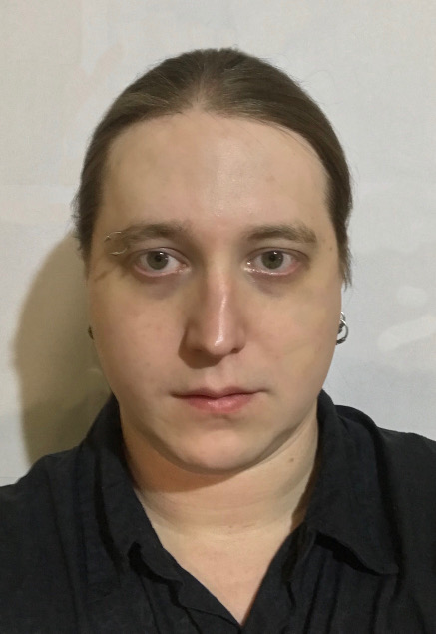
Oleg Starcheus

Contact Details

4-1, Mozhayskoe shosse, apt. 297
121374
Moscow
Russia

+7-495-443-85-75
+7-964-522-82-82
starcheus.o.u@gmail.com

Personal information

Date of birth
- September 15 1987.

Sex
- Male.

Family status
- Single.

Job objective

Freelance Translator (English-Russian)
- I would like to get a position of English-Russian Freelance translator to use and evolve my professional skills and knowledge of English, and make it easier for people finding and getting the information in the known language.

Education

I have no formal education in English, but I was studying it for 10 years, using various resources (online courses, mobile and PC applications, books etc.). I had 1 year of scholarship in linguistic university.

Work history (relevant only)

Monitoring specialist, “Manzana” Ltd.
From September 2017 till present

  - Constant monitoring of availability and flawless operation of several web-servers via Advanced Host Monitor and web-mail reports.
  - Prompt noticing of responsible executives in case of malfunctions.
  - Analysis of malfunctions depending of urgency, server type, malfunction type, time of the day, repetition rate, etc.
  - Part-time job in nighttime, 3-5 days a week, with 8-hour shifts.

Freelance translator, Booking.com, LLC

From May 2014 till February 2018
    - English-Russian translation of hotels descriptions and relevant information.

Freelance translator, “Agro XXI” publishing house
From September 2012 to May 2014

  - English-Russian translation of various articles (agricultural subject) for website and magazine.

Tourism manager, “Sirius Company” Ltd.
From August 2011 to October 2014

  - Client support.
  - Booking tours, hotels, etc.
  - Other responsibilities: website content-management and support,
computer hardware and software support, client and partner
meetings, creating local tourist routes, etc.

PC operator, “ProSoft-M” ZAO.
From February 2008 to April 2008

  - Transfer text from scanned images to electronic database. This included old, often almost unreadable archive cards with handwritten text and highly-specialized terms, so they could not be processed by a software.

Skills

Experience in English-Russian translation
- 2 years of work in agricultural publishing house as a freelance English-Russian translator.
- 4 years of work for Booking.com as a freelance English-Russian translator.
- Several one-off projects as a freelance English-Russian and Russian-English translator.

Experience in travel agency work
- 3.5 years of permanent job in travel agency as tourism manager.

Experience in using TMS
- 4 years of experience with Google Translate Toolkit
- I had been working with ABBYY Aligner for some time.

Abilities

- Personal time-management.
- High trainability.
- Used to work on the result.
- Experienced PC user.

Additional information

- I have 2 broadband internet access channels at home, and mobile 4G internet access. I also use laptop as my primary PC. That enables me to be online anytime and anywhere.

