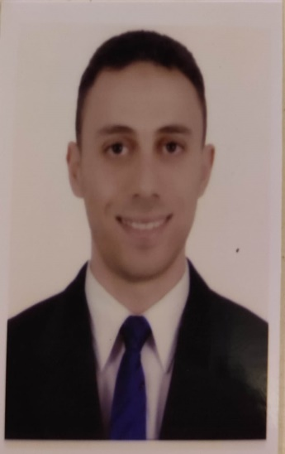
Address: 8th EL Imdad w El Tamween blocks - Nasr City
Email: Muhammed.Sarh@gmail.com
Phone: 01146440067
Birth Date : 26/6/1989
Military Status: Exempted
Marital status: Single

Muhammed Shehata Ragab

Seeking a challenging position in a reputable institution where my academic background and interpersonal skills are well developed and utilized.

Educational Qualification
Master degree in private law (LL.M.)  Bachelor in law ((LLB degree), English section |  | Ain Shams University 2020  Ain Shams  University 2010
Thanwya Amaa | AL Maaref Language School | 2005 – 2006

Academic Courses
      - Professional career certificate in Legal &UN Translation - American university in Egypt - School of continuing education.
      - Legal drafting certificate – Ain Shams University
      - ICDEL : Word, Power Point, accesses and Excel.
      - EDU Egypt certificate

Seminars
- The relevance of the International Criminal Court for Peace and Justice. Friedrich Ebert Stiftung in cooperation with League of Arab States, Ministry of Foreign Affairs of Germany and Goethe-Institute Agypten (30 January; 29-30 October, 2008; Cairo).

- Assured communication skills both written and oral. Confidence in addressing individuals and large groups in a clear and concise manner at Law Society functions and academic presentations

Work Experience
- Educational center “AIC”:
From December 2013 - uptill now
“ Co-Founder of Private business and a freelancer law lecturer “
- Undertake the responsibilty of making market research for center to compete in the market.
- Manage staff and provide them with training about how to deal with upcoming prospects.
- contribute in the process of financial spendings through the month.
- Manage meetings with stakeholders and owners inorder to develop the center image and budget.
- Give lectures to law school students in civil, criminal , administrative and private international law.
- Vodafone UK
From June 2013 - up till December 2013
- " International account advisor "
- Undertake international phone calls and manage clients complains over the phone and try to solve them .
- Reviewing and evaluating received calls from the whole department to provide eduquate report with fulfillment of supports, financial converts and conditions terms.
- Manage with head of call center team the scripts for recived calls for rest of staff
- Contribute in process for developing Vodaphone policies, procedures, and get approval authorities.
.
Genius for learning tools:
From December 2010 – up till June 2013
“ Office co-ordinator “
- Reciving all the calls for the office.
- preparing a monthly report with all office expenses.
- Manage all dates with customers who came at office.

Relevant Skills
Computer Skills | - Word, PowerPoint, Excel, Windows, Outlook and Internet Browsing.
Programs | - Operating systems: Windows Vista and Linux Mandrake  - Very good Internet research skills.
Languages | - Arabic (Mother Tongue), English; V. Good, Deutsch: Fair.

