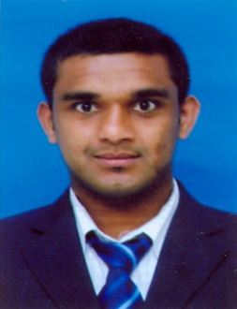
M.R. Mohammed Ali linguist
DOB 08th October 1982
75/85, Madurapura, Denipitiya 81730, Weligama, Sri Lanka
+94-771773252, +94-783464616(for WhatsApp & Wechat),
rasickali@yahoo.com, rasickali@gmail.com

Objective
To work with my passion, skill, knowledge & experience where I find my strengths. To serve the global community where I am really committed. I would like to introduce myself as a dedicated, honest and creative candidate who always tries to finish the assigned project at required time in quality.

Education & trainings
Beijing University of Aeronautics and Astronautics (Sep 2005 – Jul 2009):
Bachelor of Science in Flight Vehicle Designing and Engineering
Beijing Language and Culture University (Sep 2004 – Jul 2005):
Post Graduate Diploma in Chinese Language
Sri Lanka Institute of Tourism & Hotel Management (April 2016 – October 2016):
Training of National Tourist Guide Lecture

Experience
I am working as a translator since 2010. I am experienced as both internal & freelance translator. Internal jobs mostly related to administration & interpretation between management, employees and the clients. As a freelancer my role mostly depend on translation & proofreading. I am also experienced in creative writing & Transcreation etc.…
The some main fields I am experienced in,
- Medical Translation
- Localization
- Legal & Crime case documents
- Technical Translation
- Privacy policy & terms & Conditions
- User interfaces
- Information Technology
- Control Panels of Machineries and Software’s
Additionally, I am not limited to a specific field and I would welcome any field.

Companies I have worked for
Airbus China Limited - China
Vance info – China
HP Computers - China
RDS Translations – UK
International Cricket Council - Dubai
China Harbor Engineering Company– Sri Lanka

The tools I am experienced to work with
Memsource
Guild Task
Almost all the Chinese online platforms
AutoCAD
(Note: I can manage any CAT tools according the requirement)

Languages of the services offered
English (High proficiency), Tamil (Native), Sinhalese (Native) & Chinese (High proficiency) are the languages which I am giving services.

Skills
MS Office applications
CATIA V5
AutoCAD

