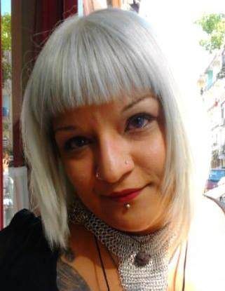
Name: Nilüfer Almira Taşkın

Contact Information
City: İstanbul
Phone: 0538 013 05 40
E-mail: vintersang@gmail.com
Education
High School: FMV Ayazağa Işık Lisesi
University: Anadolu University – Cultural Heritage and Tourism

Native language: Turkish
Pairings: English<->Turkish
Experience: 6 years
Tools and software: Microsoft Office, SDL Trados, Subtitle Workshop, Subtitle Plus, Spot 4.4, Adobe Photoshop, Corel Draw, Sony Vegas.

October 2014 On-going | Steptohealth - Sagligabiradim (web based)  Translator-Writer  Translating and/or writing articles for their Turkish website
November 2014 Project based | Language Insight (London)  Translator-Interpreter  Voice to text and text to text market research translations. Discussion group interpretations.
December 2012 On-going | Big Bang Yayınları (Ankara)  Translator  Fantasy, Sci-fi, horror book translator.
May 2011-Project based | Mirora Tercüme (İstanbul)  Translator  Freelance medical and technical translator.
March 2010-Project based | Hedef-Grup (İstanbul)  Translator-Interpreter  Voice to text and text to text market research translations. Discussion group interpretations.
September 2009-Project based | Eksen Research/Mirror Translation (İstanbul)  Translator-Interpreter  Voice to text and text to text market research translations. Discussion group interpretations.
2010 July / 2012 January | MT Production (İstanbul)  Translator  Subtitle and voice-over translations for various shows on Digiturk, Show TV, Show Plus and local television channels.
2008 June / 2010 May | Aton Production (İstanbul)  Translator  Subtitle and voice-over translations for Discovery Channel and Bloomberg.

