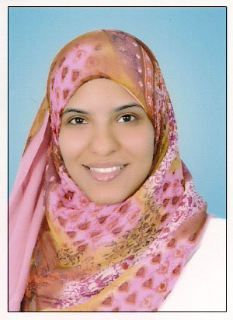

C.V.

Personal Information:
- Name: May Hafez Al-sha’ar
- Gender: Female
- Age: 24 years
- Date of Birth: July – 03 – 1987.
- Nationality: Egyptian
- Driving License: Available
Objective:

- To work in an organization where I can prove my skills and develop my career

Education:
- 2004: Graduated from high school from Alfarouk Islamic Language School
- 2004-2009: Ain Shams University ( Faculty of Pharmacy)
- Graduate Class Year Of 2009
Languages:
- Arabic: Mother tongue
- English: Excellent spoken and written
- French: Fair
Computer skills:
- Good Knowledge of Office 2003 & 2007 (Excel, Word, PowerPoint etc...)
Activities
- Participated in charity work in nongovernmental organizations such as Alzahraa Association

Training Courses attended:
- July 2005: Quality control Dept in Novartis.
- July 2006: Sales Dept in Sanofi Aventis
- July 2007: Production Dept in Sanofi Aventis
- August 2006, 2007, 2008: Al-zahabeya Pharmacy
Working Experience:
- December 2009 – July 2010: Worked at “Quintiles” as Site/Project Start Up Coordinator for four months, then as a Clinical Trial Assistant at a sponsor dedicated department in the same company
- Responsibilities included
ICF Adaptation, Translation and back Translation
Protocol Synopsis Translation
Protocol and some other documents translation review
Managing order & completion of Inhouse files
Project Purchases
Safety letters & study documents distribution
EC & MoH submissions & IP & Lab Kits shipment facilitation
Investigator payment Calculations
Contacts:
- Telephone: 02 22909863
- Mobile: 0101510081.
- Address: 2B Masjed Alnady Street Almerghany Heliopolis, Cairo, Egypt
- Email: may_361@hotmail.com

