C u r r i c u l u m V i t a e
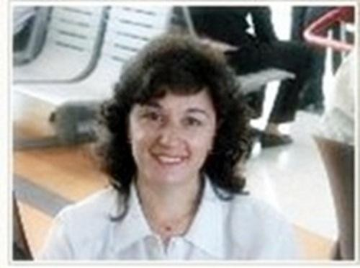

M a r c e l a G r e c o L a n i e l l a

Sworn Spanish Translator

Buenos Aires, Argentina (GMT-3)

Education
- GRAPHIC DESIGNER. Universidad Tecnológica Nacional (UTN), Buenos Aires, Argentina (2013-2014).
- SWORN SPANISH TRANSLATOR. Universidad de Belgrano. Buenos Aires, Argentina (2004-2005).
- LITERARY, SCIENTIFIC & TECHNICAL SPANISH TRANSLATOR - IESVL “Juan Ramón Fernández", Buenos Aires, Argentina (1997-2003).

Linguistic Pairs

- English/ Spanish
- Spanish/ English

Fields of Specialization

- Life Sciences
- Law
- Social Sciences
- Technical

Legal Documents Translated (2005-2015)
- Birth Certificates, Marriage Certificates, Death Certificates
- Diplomas, College Transcripts
- Powers of Attorney, Criminal Records
- Law suits, claims, contracts, agreements, by-laws.

Further Information

- Professional Membership – Colegio de Traductores Públicos de la Ciudad de Buenos Aires - www.traductores.org.ar
- CAT tools: TRADOS STUDIO 2011; WORDFAST; OMEGA T.
- SOFTWARE other: Windows, MS Office, PDF editing. ADOBE Illustrator, InDesign, Photoshop, Dreamweaver. Corel Draw 7.
- PROZ.COM member -URL: http://www.proz.com/pro/35428
- Daily production: 2,500- 3,000 words
- Skype: marce_greco@hotmail.com
- Hight-speed internet connection

