CURRICULUM VITAE
VARANASI, UP, INDIA
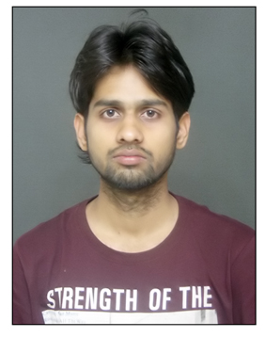
POSTAL CODE- 221005
E-MAIL ID- mishra4classmates@gmail.com
CONTACT NO/skype- +918896164116
DOB- 27/05/1992
Manish kumar mishra

WORK EXPERIENCE:-

- WorK for Translation/subtitling as Freelancer (five years)
- Listen to recorded conversations and provide translations.
- Maintain records of results dealing with translations in order to build a best-practice manual.
- Reviewing and proofreading mother-tongue text.

EDUCATIONAL QUALIFICATION :-

- Master of Arts from BANARAS HINDU UNIVERSITY (2016-2018).
- Bachelor of Arts from BANARAS HINDU UNIVERSITY (2013-16) with first div. (73%).
- Intermediate (science) from NIOS (2010)with first div. (64%).
- High school from Holy mission high school, bihar (2008) with first div. (74%).

SKILLS AND INTERESTS :-
- Hardworking, dilligent individual with good communication with interpersonal skills.
- Knowledge of basic operations on computer, Audio/video editing, Microsoft office, .
- Knowledgeable and experienced translator able to work in multiple environments.
- Fluent in multiple languages with knowledge of cultural and regional variations
- Proficiency in ENGLISH and HINDI..
- Familiar with translation software tools.
- Able to work to tight deadlines.
- Highly skilled in Word, Excel and Microsoft Outlook.
- Appreciation of active thinking and good communication ability.

