Resume

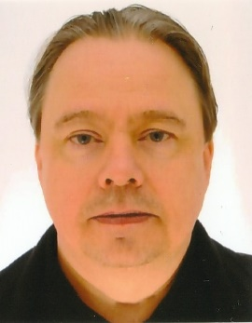

Name: Lárus Erlendsson

Address: Tjarnarból 4, 170 Seltjarnarnes, ICELAND
Email: laruse@internet.is
Mobile: +354 6931154
Skype ID: larus.erlendsson

Summary:

I am a native Icelander with working background and university education in the computer/software field. Recently I have been working as a full-time freelance translator in the language pair English-Icelandic, having now over 5 years of experience in this field of work.

I have provided translation and proofreading services for various translation companies and clients in various subject fields including technical (automotive, IT, various equipment), medical, legal, marketing and finance, using various translation software tools.

I have currently translated approximately 2.5 million new words and proofread/edited over 1.5 million words (see “Experience” below for detailed information). The projects I have worked on include localization of websites and UI-strings, translations of manuals and instructions for vehicles, machines, computers, software, medical equipment, consumer electronics, electric appliances, and safety equipment. Projects also include translations of various general medical, legal, marketing, and financial content

Translation software tools:

Across, Adobe Acrobat, Excel, MateCat, MemoQ, Memsource, SDL Trados Studio, Transifex, Transit NXT, Transtool, Verifika, Word, Wordbee, Wordfast Pro, Workbench, Xbench, XTM, XTM Workbench.

Experience (as a translator):

2017- Freelance translator in the language pair English-Icelandic.

Outsourcers and approximate number of translated words:

Outsourcer | Word Count Translation
TLMG Group | 654.000
CBG | 303.000
Moravia | 284.000
Universal Translation Services | 238.000
BeConnected | 123.000
Coral Knowledge Services | 105.000
Medtronic Translations | 105.000
CLS 4-Text | 91.000
Ad Verbum | 58.000
Other | 536.000
Total | 2.497.000

Translated words by subject fields:

Subject field | Word Count Translation
Automotive | 844.000
IT | 488.000
Medical | 319.000
Various equipment | 495.000
Legal | 192.000
Marketing | 85.000
Finance | 36.000
Other | 38.000
Total: | 2.497.000

Experience (other than translator):

1985-2014 Software specialist/programmer.
Companies: 1999-2014 Ax hf., Hugur-Ax ehf., Advania hf; 1996-1999, Kerfi hf.; 1985-1996 Sjóvá hf.

Education:

B.Sc. in Computer science, University of Iceland (1987)

Courses/seminars:

Accredited accountant, University of Iceland (2016)
Excel and accounting, Promennt (2015)

Languages:

Icelandic:
Native speaker.

English:
Good skills. Very good reading and writing skills.

