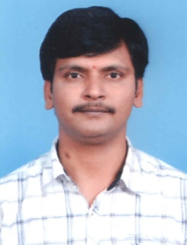

AREAS OF EXPERTISE

Content creation

Article writing

Researching stories

Rundown Management

Bulletin Producer

Story based Reporting

Personal Finance Articles

PROFESSIONAL

Typewriting

MS Office

NSE Equities Certification
(National Stock Exchange)
NSE Derivatives Certification

NSE Currency Certification

PERSONAL SKILLS

Accuracy

Conceptual thinker

Competitive

PERSONAL DETAILS

Krishnamohan Tangirala

MIG 1-98, 9th Phase

KPHB Colony

Hyderabad -500085

Tel: + 91 40 40150584(H)

Mob: +91 88011 36270

Email: info@krishtan.com

DOB: 07/03/1981 Nationality: India
Krishnamohan

Sr. Copy Editor

PERSONAL SUMMARY
A multi-skilled copywriter with good all-round writing and creative expertise.

Very capable with an ability to identify and then deal with the issue into crisp, compelling, creative and informative copy. Capable copy writes the topic that will have a real impact on the lives of people. Having excellent interpersonal skills, a good communicator, and emotionally mature; calming and positive temperament with an understanding disposition.

Now looking for a new and challenging position, one which will make best use of my existing skills and experience and also further my personal development.

SUMMARY OF QUALIFICATIONS
Vast experience in writing, editing and managing high-quality written working knowledge of standard style guides.
Outstanding knowledge of research methods and techniques.
Wide knowledge of publishing functions, process, and formats.
Familiarity with journalistic research, methods and techniques
Ability to understand applicable rules, regulations, policies and procedures.
Proficient with MS Office products - Word, Excel, PowerPoint, and Outlook
Excellent line editing, copy editing and proofreading skills
WORK EXPERIENCE
Copy Editor in HMTV Jun 2014 – till to date.
Copy Editor in CVR News Sep 2012 – June 2014.
Franchisee admin for-
Fortune Financial Services Oct 2010 - Aug 2012.
Content writer in www.telugustockmarket.com Oct 2010 - Aug 2012(Part time).
Copy Editor in Studion News Nov 2008- Sep 2010.
News Contributor in Eenadu News daily Jan 2006 - Oct 2008.

DUTIES:
Writing short focused concise and engaging material for different markets.
Carrying out research for articles.
Working in a range of different writing styles across various platforms.
Working with a talented mix of writers and seniors.

KEY SKILLS AND COMPETENCIES
Flexible, versatile and able to quickly move between burning issues.
Ability to produce creative and informative writing. Impeccable spelling and grammar.
Experience of numerous media platforms i.e. TV, Web.
Strong attention to detail.
Can work well within a team.
A natural interest in reading and writing.
Ability to produce outstanding copy under pressure. Able to meet deadlines.
Totally comfortable writing in multiple styles and for multiple formats.

ACADEMIC QUALIFICATIONS
Bachelor of Arts in Economics, Public Administration and Sociology

Dr. B.R.A.O.University

