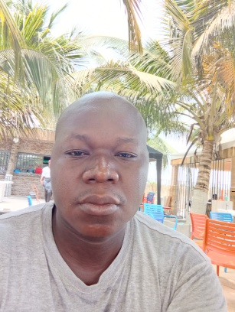
N’ZI KOUACOU ATTIOLOU ARMEL
Ivorian
Born to Abengourou
Married with one (1) child
+225 07-59-51-33-25
nzi_armel2006@hotmail.fr / nziarmel2006@gmail.com

SCHOOL CURRICULUM AND UNIVERSITY

January-March 2015: Attestation in Industrial Automation (AUTOMELEC)
February-March 2015: Certificate in Industrial Automation (Cocody Technical High School)
2010-2011: BTS (Brevet of senior technician) Option Industrial Computing and Maintenance (IST Colombe d'Abidjan)
2004-2005: Bachelor of Science degree (SEPI Modern Secondary school of Abidjan)
2000-2001: BEPC (SEPI Modern Secondary school of Abidjan)

COMPLEMENTARY TRAININGS AND SKILLS

SINCE JULY 2015: Instructor in INDUSTRIAL AUTOMATION Cocody Technical High School
PROGRAMMING LANGUAGE: CONT (LADDER), FDB (FLOWCHART), SFC (GRAFCET)
SOFTWARE: PL7 PRO, MICRO-WIN, SIMATIC-MANAGER, WIN CC
AUTOMATON: Siemens (S7 200, S7 300), Scheider TSX-Micro
2012: Training in Installation of Solar Panels in SOLINEL

PROFESSIONAL EXPERIENCES

27 April - 26 June 2015 (3 months): Refresher training in INDUSTRIAL AUTOMATION in AUTOMELEC
In partnership with the AGEPE.
December 2011- March 2012 (3 months): Practical training in IT Maintenance in SOLINEL
(IT Solution and Electronics)
July-September 2009 (3 months): Input operator at the ONI (National Office of Identification)
December 2008- March 2009 (4 months): Enumerator officer at the INS (National Institute of Statistics)

COMPUTER MAINTENANCE: Very good knowledge
NETWORKS: Wiring and Network Configuration, Windows Server 2008 installation
WEB DEVELOPER: HTML5, CSS3, PHP, Notion en MYSQL
INFOGRAPHICS: (Paint, Photoshop).
INTERNET: Very good knowledge
SOFTWARES: Office (Word, Excel, PowerPoint), Notepad++, SDL TRADOS and many others
ACCOUNTING: General Accounting
Knowledge of stock market platforms and binary options

LANGUAGES
French: Excellent (read, written and spoken)
English: Academic (read, written and spoken)
VARIOUS

Qualities: promptness-dynamism-self control
Advantage: easy understanding
Sport: football, jogging

TRANSLATION EXPERIENCE

Since 2022: Freelance Translator in translation on many projects for Polilingua

Since 2018: Freelance Translator in translation on many projects for Profpereklad

Since 2018: Freelance Translator in translation on many projects for Saltlux

Since 2018: Freelance Translator in translation on many projects for Daytranslation

Since 2016: Freelance Translator in translation on many projects for Onehourtranslation

Since 2016: Freelance Translator in translation on many projects for IDEAL Lingua
Translation

2013: United Nations online volunteer translator. I have worked as a Translator on the translation of the Zero Draft 2016 for a UN conference in Madagascar and I also worked for the UN Women and many other UN projects.

NB: more than 5 years of experience in the technical field

I have worked as a Translator for many technical projects as Automotive (user manual, guideline of parts spare…), engineering, technology, Games, IT, Marketing, Market research, Claim, Economics, Public Health, I have translated several translating documents to relating to Safety Data.
Machine translation post-editing (MTPE) in the technical, marketing, general
fields...

I have worked on many projects in the localization service

Language pair: English – French (France)/ French (Canada)

Translator Software: SDL TRADOS STUDIO / SmartCat…

