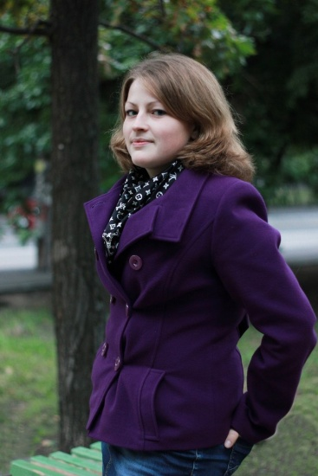
Covering Letter
Julia Klokun
Mobile: 063 614 63 30, email: aspen_tree@ukr.net
____________________________________________________________________________
Borodyanka township,
Kyiv region, Ukraine

A person who has a cheerful outlook on life and serious approach to the work is looking for a new job. I have an experience working as a translator and a teacher of foreign languages. I am seeking a career that requires my knowledge of foreign languages and new skills which I have to develop.
Education
_____________________________________________________________________________
2011 Borys Grinchenko Kyiv University
Philology (teacher of English and French languages) – Bachelor’s Degree
2011 National Pedagogical Dragomanov University
Philology (translator of English language) – Bachelor’s Degree
2013 National Pedagogical Dragomanov University
Language and Literature ( English and German languages) – Master’s Degree
2013 (October – December) “MAK CO” Educational Centre
Gained B1 level in German Language

Relevant work experience
_____________________________________________________________________________
2010 – June 2013 Maidanivka Primary and Secondary General School
Teacher of English and German languages. This position has given me a great experience to cooperate with people and children. After this work I feel myself confident and comfortable speaking to large groups. Furthermore I have obtained an immediate experience to teach children aged 6 to 15.

June 2013 – present “MAK CO” Translation Agency and Educational Centre
Translator and trainer
Translate different kinds of documentation: economic, educational, judicial and technical. Developed skills in preparing documents for notarial certification, legalization and apostilization. Learnt to work under stress conditions. Also gained experience to work as a trainer of foreign languages for people aged 3 to 35 years old.

Other competencies _____________________________________________________________________________
Languages: Ukrainian/Russian – native, English – advanced, German – intermediate, French – elementary.
Competent user of PC, office machines and equipment.
Ready to broaden horizons, knowledge and skills in different fields.
No bad habits.

