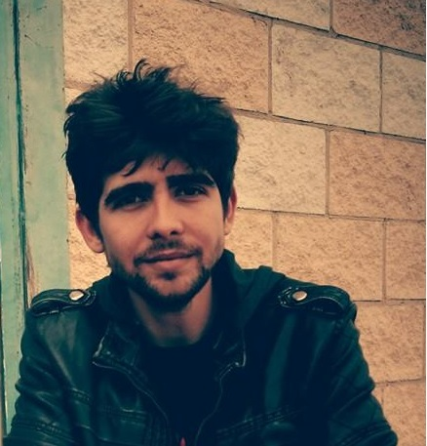

***Freelance Translator & Proof-reader***

**Juan Manuel Baquero VÁzquez**

C/San Isidro, 99

Los Palacios y Vfca. 41720

(Seville) SPAIN

* : (+34) 650283996

 : baquero.translations@gmail.com

*I am a highly-motivated and confident EN/DE>ES translator & proof-reader skilled in a wide range of translation fields. Very capable to identify and then deal with a client’s needs by translating them into appropriate linguistic solutions. Now looking for a new and challenging position that allows me to make best use of my existing skills in order to foster not only my professional but also my personal sphere.*

**WORK EXPERIENCE __________________________________**

2014 March – Till Now : **DE-ES Freelance Translation Vendor at Amazon**

2012 – Till Now : **Freelance translator & proof-reader. ≈ 2,500 words per day**

***Freelance translator & proof-reader for particulars and companies****, i. e. YTLT Traducciones (Sevilla), LogisCenter, Unión Editorial, Gourmet Oliva, IMF Formación, Successful Spanish Translators S.L., etc.*

2012 – Till Now: **Literary translator – Unión Editorial – Publishing sector**

* “*The State*” by Franz Oppenheimer
* “*Our Enemy the State*” by Albert Jay Nock.
* “*Literature and the Economics of Liberty: Spontaneous Order in Literature*” by Paul A. Cantor and Stephen Cox.

2011 – Till Now: **Volunteer Translator**

* NGO *“Global Voices”, European Citizen’s Initiative “Fraternité2020”* and OmegaT translation projects*.*

2014 Specialization courses in **Financial Translation** and **Patent Translation** by renowned **AulaSIC**.

|  |  |
| --- | --- |
| 2006-12 | University Pablo de Olavide, Seville, *Bachelor’s Degree in Translation and Interpretation*. |
| 2011-12 | University of Leipzig, Germany, *Trainee in the Institute for Applied Linguistics and Translatology* in the Erasmus Practicum Programme. |
| 2009-10 | University of Cologne, Germany, *Erasmus student.* |

**GENERAL SKILLS**:

*Communication, teamwork spirit, problem solving approach, confidence, perseverance, motivation, leadership, organization and ability to work under pressure.*

**OTHERS SKILLS _________________________________**

*Freelance Translator &*

*Proof-reader*

**Juan Manuel Baquero VÁzquez**

C/San Isidro, 99

Los Palacios y Vfca. 41720

(Seville) SPAIN

* : (+34) 650283996

 : baquero.translations@gmail.com

- Excellent knowledge in MS-Office

- Reliable, pro-active and diligent partner. Persistent to achieve desired results.

- OmegaT, Kompozer, Adobe, IE, GCr, FX, Scribus.

**Interest & Hobbies :** Reading, travel, family, nature, friends, translation & culture.

**EDUCATION_________________________________________________**