First name | 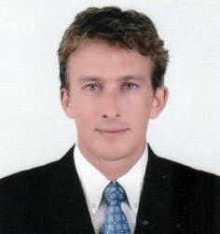  Jeroen
Middle name | Martijn
Surname | de Gier
97 M 15 Nongraweang
Amper Meung Nakhon Ratchasima
Nakhon Ratchasima 30000
THAILAND
Place of birth | Naarden - NL
Birthday | 31.12.1976
Nationality | Netherlands
Education
1982 - 1986 | Primary school Netherland - Weesp/Jan Leegwaterschool
1986 - 1991 | Secondary school Netherland - Hilversum/Stimulans
1991 - 1995 | College Netherland - Electrical low voltage & high voltage
1995 - 2000 | University of Business - Hotel management - Amsterdam/MBO
2000 - 2003 | University of Business - Hotel management Teacher - Amsterdam/MBO
Work experience
1991 - 1994 | DNR Weesp Netherlands - Service technicians
1994 - 2001 | Martinair Royal Netherland - catering manager
2001 - 2004 | Dudoc college Hilversum Netherlands - Teacher for young adults  I have taught in my country, young adults between the age 15 - 22 in the subject of hotel management.  Since I speak fluently English, I teach English language to some children in my village in the weekends in my free time,
2004 - 2006 | International experience - travel in different countries
2006 - 2008 | Owner of Hotel and Guesthouse PC Club house in Chonburi Thailand
 | Additionally, I started as part time translator in the language pairs EN-NL and NL-EN. Since 2007, I started to work as full time translator. I have experience with CAT tools like Trados, Wordfast, MetaTexis and some open source CAT tools. During my profession as a translator I have translated many documents in various fields such as consumer electronics, automotive industry, it, real estate investments, tourism and less common subjects like press releases, study material and consumer surveys.
Languages | English, Dutch (fluently)
 | Thai & German (understanding and talking conversation on medium level)

R e s u m e

