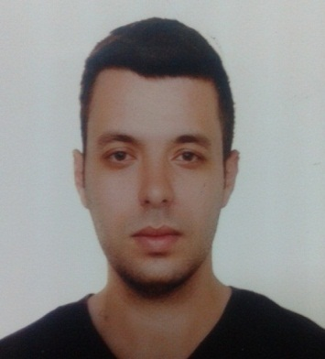 Jehad Deeb

About Me
Age : 27
Date of birth : 18/6/1989
Nationality : Syrian
Languages : Arabic – English
Address : INSHAAT– HOMS - SYRIA
Telephone : 00963 930081169
Email : jehad.deeb.it@gmail.com
Marital status : single
Profile
I have been working at BANIAS refinery company as a server administrator which include administrating , troubleshooting ,and configuring servers for almost two years . I have worked on server 2008 with ISA server installed on it.
During my work in the ministry of culture , I was responsible for implementing and configuring network devices and computers.
I also taught network administrating at AL BAATH university for almost a year and got a great experience in communication.
I started working in translation from English to Arabic with Syrian Society for Scientific Research
From MAY- 2016 until know.
I have been translating MIT open course and I am doing a very good job
Key Competencies
- Leadership | - Team Work
- Communication | - Work under pressure
Career Summary
- From 2014 – 2016 ISA server administrator BANIAS refinery company.
- From 2012 – 2014 Technical support engineer ministry of culture.
- From 2013 till now technical support NAS ISP(LLC company in Damascus).
- From 2016 till now translation for private organisation
Professional Development
- I attended courses in MCTP
- I also took TOEFL courses .

Education
- Bachelor's in information technology engineering with major of system and network management (from 2007 to 2012 )

- MASTER in information technology at AL-BAATH university (from march 2016 till now )

- Translation at AL-BAATH university (from 2014 untill now)
Key I.T Skills
- Server Administration
- Computer maintenance
- Operating system (windows , Ubuntu, Server 2008, ISA server)

References
Available up on request

