PERSONAL INFORMATION | Hubavena Georgieva Dimitrova
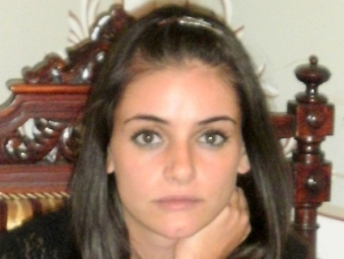 | 1 Maragidik, floor 1, apt. 3, Plovdiv 4000, Bulgaria
 | Replace with telephone number 0886063946
 | hubavkaaa@abv.bg hubavenaland@gmail.com
 | Sex female | Date of birth 02.09.1986 | Nationality Bulgarian

JOB APPLIED FOR  POSITION | Translator/Linguist with English and Bulgarian

WORK EXPERIENCE

November 2015 – till now  February 2012 - till now  November 2013 – February 2014 | Translator with English and Bulgarian
 | “Freelance translator
 | - Translating various documents and texts from English into Bulgarian
Business or sector Education, Courses, Translations

Individual Teacher of English
- Teaching English Language, English Grammar, English Pronunciation
Business or sector Education, Science

Travel Writer in English and Bulgarian; Chief Editor in English
you-hotels.com
- Writing travel articles about different cities from all around the world
- Editing all travel articles written in English
Business or sector Arts and Entertainment

EDUCATION AND TRAINING

October 2013 – November 2014  November 2011 – October 2013  October 2007 – December 2011  September 2000 – May 2005 | Master’s Degree of English Philology – Linguistics and Translation  The Paisii Hilendarski University of Plovdiv, Bulgaria  Linguistics, Technical Translation, Legal Translation, Literary Translation, Translator as a Profession, etc.  Master’s Degree of English Language and Methods  The Paisii Hilendarski University of Plovdiv, Bulgaria  English language, English morphology, English syntax, Methods, etc. | Replace with EQF (or other) level if relevant
Bachelor’s Degree of Special Education

The Paisii Hilendarski University of Plovdiv, Bulgaria
Special teaching, Speech therapy, Mental Retardation Teacher, etc.

English Language Learning Class

Secondary School Neofit Rilski, Harmanli, Bulgaria
English language, Bulgarian language, Maths, History, etc.

PERSONAL SKILLS

Mother tongue(s) | Bulgarian
Other language(s) | UNDERSTANDING |  | SPEAKING |  | WRITING
 | Listening | Reading | Spoken interaction | Spoken production
English | Excellent | Excellent | Excellent | Excellent | Excellent
 | C2
Levels: A1/2: Basic user - B1/2: Independent user - C1/2 Proficient user
Common European Framework of Reference for Languages

