CURRICULUM VITAE

HIYA CHAKRABORTY 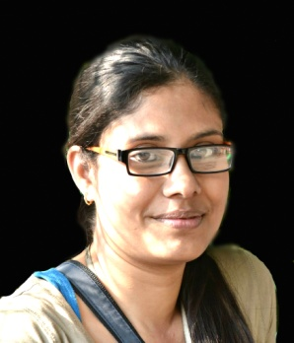
MOBILE NO. - 9475442498
E-MAIL ID: hiya.c89@gmail.com

EDUCATIONAL QUALIFICATION
EXAM | BOARD/UNIVERSITY | YEAR OF PASSING |  | PERCENTAGE OF MARKS
M.Phil. in Bengali | Jadavpur University, Kolkata | 2014 |  | Successfully passed
M.A. in Bengali with Linguistics specialization. | Jadavpur University, Kolkata | 2012 |  | 68.9
B.A. With Bengali (hons.) | Jadavpur University, Kolkata | 2010 |  | 68.4
Higher Secondary | W.B.C.H.S.E | 2007 |  | 76.2
Madhyamik | W.B.B.S.E |  | 2005 | 78.875

EXTRA CURRICULAR ACTIVITY:
- I have experienced a field work on Linguistics in a Santali village at Shantiniketan.
- I won a district basis music competition organised by Bangiya Sangeet Parisad for three years constantly.
- I have completed 4th year music examination with distinction in Rabindra Sangeet.
PERSONAL PROFILE:
NAME : HIYA CHAKRABORTY
FATHER’S NAME : ANUPAM CHAKRABORTY
PRESENT ADDRESS : 11,Baderaipur Road, Kolkata 700032
PERMANENT ADDRESS : Rabindrapally (near-D.I.Office), P.O-Suri
Dist.-Birbhum, Pin-731101(W.B),
Mob.- 9475442498

DATE OF BIRTH : 26Th February of 1989
SEX : Female
NATIONALITY : INDIAN
HOBBIES : Reading Books, Listening to Music, Singing Song
LANGUAGE KNOWN : Bengali, English, Hindi
DATE :
PLACE :
SIGNATURE

