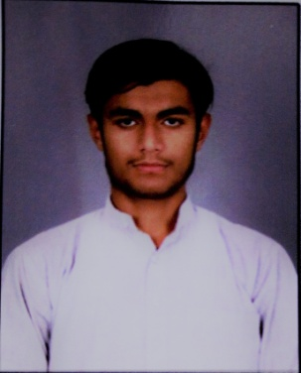 | HAMZA SULTAN  11/43 ,CHILLI PARA SHAHGANJ AGRA  YOOSHAISLAMIC@gmail.com Mobile: +91 9899873019

Objective:

To work in an innovative and challenging environment where I could explore my expertise that I obtained over the years, to further hone my skills as a versatile professional and gain valuable experience for future prospects.

Interpersonal Skills:

Work effectively and efficiently in harmony with different people. Good communication skills. Open to ideas and suggestions.

Education:
- 10th from Jamia Islamia Sanabil, Delhi in 2014 with English, Arabic, Science, Social Studies & Islamic Studies.
- 12th from Jamia Islamia Sanabil, Delhi in 2016 with English, Arabic, History, Social Studies & Islamic Studies.
- Advance Diploma in Modern Arabic Language and Translation from Jamia Millia Islamia, Delhi in 2017

Freelanced:
Worked as a freelance translator on Arabic medium school ser.

Languages Known:

- Arabic, English, Urdu and Hindi

Computer Proficiency:

- Well-versed in using computer with working knowledge of MS Office (with typing skills in Arabic & English), Inpage (Urdu Word-processor),coral draw , Internet enabled work and comfortable with working on youtube. Well versed with technical working environment.

Personal Information:

Date of Birth : June 7, 1998
Marital Status : Single
Nationality : Indian
Sex : Male
Strength : A good deal of patience and hope to win, ability to work, independently as well as a team.

