GÜL TEKİN

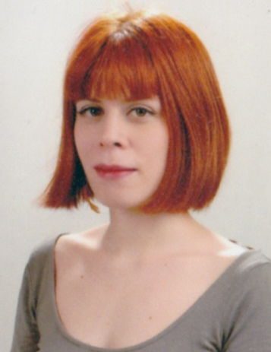

TRANSLATOR'S CV
tekin.gul@gmail.com | +90 531 818 92 90 | Bozkurt Mah. Bilezikci Sk. Ferah Apt. 73/1 Kurtulus Sisli - Istanbul 34375 TURKEY

LANGUAGES (Native language: Turkish)
English-Turkish Translator
English-Turkish Proofreader

SPECIALIZATIONS
MARKETING/FINANCIAL
Advertisement Materials, Websites, Website Localization, Financial Translations
ACADEMIC ARTICLES
Scientific Articles, Research Proposals
IT/COMPUTER
Game Localization, Website Localization Software and Hardware User Materials - User Manuals, User Interface Translations/Localization
LEGAL/SEMI-LEGAL LETTERS/BUSINESS LETTERS
Ombudsman Letters, Customer Letters
PROOFREADING/EDITING
Stylistic and Grammatical Improvement of all types of text, cross-checking of the translation against the original.
SKILLS
Experience with quality control procedures in a translation agency environment.
Good knowledge of terminology
Advanced IT skills

EXPERIENCE

2013 - Present | Qordoba | Dubai, UAE
English-Turkish Freelance Translator and Turkish Proofreader/Editor
Financial Translations, Marketing Translations
2012 - Present | Readypens | Los Angeles, USA
English-Turkish Freelance Translator and Turkish Proofreader/Editor
Marketing Translations
2012 - Present | Anecsys Translation | Melbourne, Australia
English-Turkish Freelance Translator and Turkish Proofreader/Editor
2011 - Present | TTC Language Services Ltd. | Chelmsford, UK
English-Turkish Freelance Translator and Turkish Proofreader/Editor
Translation/Proofreading experience in a wide range of fields.
Main titles:
Computer Games (online games, mobile games, mmorpg, casino, etc.) – Babel Media
User manuals of technology products - Samsung
Training materials - Xerox
Financial Ombudsman letters
Legal documents – contracts
Marketing Translations – Mango, Xerox, Lilly
2009 - Present | Karakalem Advertisement Services | Istanbul, Turkey
English-Turkish Freelance Translator/Proofreader/Editor and Copywriter
Advertisement translations in a wide range of fields
Financial translations
2005-2009 | Strawberrynet.com
English-Turkish, Turkish-English Freelance Translator
Translations of beauty and health products.
Turkish-English, English-Turkish translations of customer correspondences
2008 | Atlantik Sound and Light | Istanbul, Turkey
English-Turkish translations of sound and light systems user manuals.
2007 | Agos Newspaper | Istanbul, Turkey
English-Turkish translations of news and articles which were published in international press.
Turkish-English translations of articles which were written by Turkish journalists.
2005 - Present
In addition to the work experiences listed above, I also work with different clients of my own.

PROFESSIONAL EXPECTATIONS
As a translator, my primary focus is on the quality and accuracy of my work. I pride myself on providing carefully crafted, stylish writing that does not read like a translation. I give all my translations a thorough review before returning them. I carefully research all terminology in specialist dictionaries and online. I believe that one of the most important things which would make me different is my interest in research. Because of this interest, I continue to develop myself and enjoy this.

EDUCATION
2013-present | Istanbul Bilgi University
Graduate School of Social Sciences
M.A. in Cultural Studies
2005-2011 | Istanbul Bilgi University
Faculty of Science and Literature
B.A. in Sociology
Film and Television (minor)
2010 Spring Semester | European University Viadrina Frankfurt/GERMANY
Faculty of Social and Cultural Sciences
2003-2005 | Nisantasi Anatolian High School
1995-2002 | Ted Ankara College

IT SKILLS
Trados
Wordfast
Windows XP
MS Office
Adobe Acrobat, FrameMaker, Photoshop
Adobe Premiere, Adobe Illustrator, Adobe After Effects

REFERENCES
Nurcan Yorulmaz
Senior Project Manager – TTC Language Services
+44 (0)1245 216937
nurcan@ttc-online.co.uk
Çağrı Karadağ
Karakalem Advertisement Services – Customer Relationships Specialist
+90 505 214 95 93
cagri.karadag@kara-kalem.net
Gülçin Latifaoğlu
Strawberrynet
+90 532 541 49 29
gulcin@europey.com

