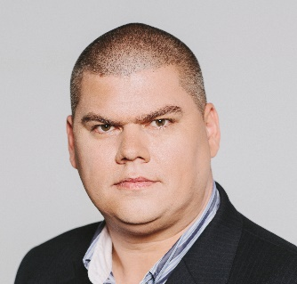
WELL ESTABLISHED ENGLISH – HUNGARIAN (native) TRANSLATOR AND PHONE INTERPRETER
_____________________________

Gabor Nemet
(Last updated January 2016.)
Contacts:
Email: | gabor@gabornemet.com
Telephone: | +34 671 146 894
Skype: | gnemet
Web: | www.gabornemet.com
LinkedIn: | http://www.es.linkedin.com/in/gnemet
Specialization:

- Government/Politics
- Business, marketing
- Technical (automotive)

Personal statement:

- Professional Hungarian translator since 1999
- Passion for natural flow
- 300+ satisfied clients
- 5 million+ translated words
- University degree in translation and interpretation (2006, University of Debrecen, Hungary)
- IAPTI, ProZ Pro, TWB membership

Competencies:

- Trados Studio 2015
- MemoQ
- MS Office
- Daily translation output: 3000 words
- Daily proofreading output: 6000 words

Key achievements:

- Completed 800 pages HU>EN about the prolongation of the service time of the Paks Nuclear Power Station in Hungary (2010)
- Delivered 100 pages EN>HU for Greenpeace Hungary entitled [r]enewables 24/7 Infrastructure needed to save the climate (2011)
- Corrected the HU website of American Airlines
- 120 pages, HU>EN tender documentation for Škoda Auto (2013)
- 5.000 segments of accounting software strings translation for Bilfinger HSG (2014)
- 100 page 3D wheel aligner machine manual EN>HU (2014)
- 150 pages, EN>HU carts, trolleys catalogue with DTP for Novotransz Kft. (2015)
- 50 page pipes catalogue with DTP for Sebők és Társa Kft. (2015)
- 98 pages, EN>HU, Safety Manual of radioactive, laser measuring devices (2015)
- 5.000 words in general medical field, survey for diabetes patients
- 4.200 words; Technical specifications, signal system pilot project HU>EN
- 13.000 words; Child adoption documents EN>HU
- 1.000 words; Declaration of performance EN>HU
- 2.000 words; Marketing material of sectional doors EN>HU
- 25.000 words; Electrical engineering EN>HU
- 50.000 words; Manual of animal slaughtering equipment EN>HU
- 10.000 words; Minutes of the annual meeting of an international retailer EN>HU
- 3.000 words; Sawmill manual EN>HU
- 5.000 words; Accounting text, annual report HU>EN
- 10.000 words; Ventilation system manual EN>HU
- 5.000 words; Construction plans EN>HU
- 10.000 words; Trial Fermentation HU>EN
- 15.000 words; Applied Biosystems Field Service Plan Specification EN>HU

Phone interpreting:

Phone interpreting that I am most proud of: confidential bond transactions for a Swiss client, transaction amount was 10 digits in USD. The work required my full attention for two weeks and all parties involved were very happy with the service I provided.

References:

Mindpower Hungary (translation agency): iecsoka@mindpower.hu
Audi Hungaria (direct client): akademie.csokor@audi.hu
KL Translations (translation agency): pm@kltranslations.com
Wood-Mizer (direct client): mkula@woodmizer.pl

Testimonials:

“He is fast-responsive and a reliable source of expert translations”
(Ana Šavli – Hieroglifi translation agency)

“Excellent work”
(István E. Csóka – Mind Power Hungary translation agency)

“Very reliable and fast”
(Kristina Marević - Outsourcer)

“He is very correct and perfect partner.”
(Evelina Dimitrova Dóczi - tourist guide at self-employed)

“We attended the same special English class together with Gabor in 1994/95 and it was evident from early on that he was very talented with languages.”
(Eszter Kocsis - Kongsberg, HR Generalist)

“We have been cooperating with Gabor Nemet since 2013 regarding the translation of documents from English to Hungary and vice versa.
The scope of his work includes:
- translating technical texts from English into Hungarian and vice versa
- editing materials
- translation and cross-cultural adaptation of advertising and mass media texts.
Gabor Nemet is a very hard-working, qualified and motivated professional. The accuracy of his translations and the ability to work under deadline pressure deserve a special mentioning. I can without hesitation recommend Gabor for any translating job or any position that requires in-depth knowledge of Hungarian and English.”
(Natálie Vachatová, NVF Agency)

Other languages:

Hungarian | native language
English | fluent
German | good
Spanish | good
Hobbies:

- Hiking
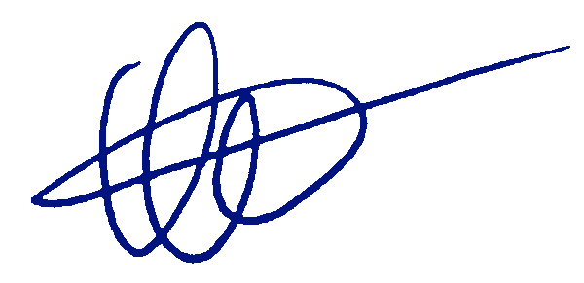
- Cooking
- Driving tractors

Gabor Nemet
01-04-2016

