Curriculum vitae
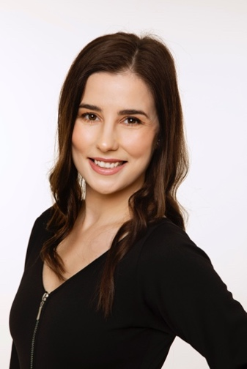

Contact information

Name: Mgr. Eva Sedláková, Ph.D.

Address: Trenčianske Teplice, 914 51, štvrť SNP 684/89, Slovak Republic
Phone number: +421 910 269 550
www: www.evasedlakova.sk, www.becampmedia.sk
E-mail: eva@becamp.sk
LI: https://www.linkedin.com/in/esedlakova/

Professional experience and employment history
______________________________________________________________________________________

BECAMP MEDIA s. r. o. June 2016 - present
(linguistic consultant, subtitler, translator/interpreter)

Language combinations:
Slovak, Czech, English, Japanese

Areas of professional linguistic expertise:
· industrial production and manufacturing (technology, QC, machinery, production and production planning, HR and general affairs)
· audiovisual translation, localization, subtitling, transcription (have translated about 450 videos so far, mainly feature films and short films for major Slovak film festivals.
Content for other clients: marketing videos, TV series, sitcoms, reality TV, drama, crime shows, children’s shows, medical shows, cooking shows, documentaries, etc.
Excerpts from specific works available upon request)
· law (primarily real estate)

Significant clients:
FUSO Industries Slovakia s.r.o., Akebono Brake Slovakia s.r.o., Ipsos Mori (UK), Scripto s.r.o., MAFER s.r.o., ARTFilm Fest, IFF Bratislava, Arvin & Benet s.r.o., Lilt (USA), Knockhundred Translations (UK), PoliLingua (USA), Deluxe Media Inc. (USA), Iyuno (UK, USA, Denmark), Visual Data Media Services, Hiventy and others

FUSO Industries Slovakia s. r. o. June 1st, 2015 – May 31st, 2016
(in-house interpreter/translator)

Language combinations:
Slovak, Czech, Japanese and English

In-house interpreter and translator at a Japanese-owned factory focused on the production of copper components for air-conditioning devices.
Translation and interpreting for Japanese members of the company management in the areas of production, QC, HR, accounting, sales, general affairs and personal matters.

PRO School Trenčín October 2011 - May 2015
(teacher/translator)

English language teacher at a language school focused on the DME teaching method.
Translator of text primarily in the field of industrial production and engineering

Masaryk University, Brno September 2011 - May 2015
(teaching assistant)

Teaching assistant and lecturer in the study program of English philology - Linguistics at the Department of English and American Studies, Faculty of Arts, Masaryk University, Brno (Czech republic).

Assistance with the tuition of courses for the 1st year of the Bachelor study program in terms of my own doctoral studies:
FF: AJ01001 Practical English I (Fall semester 2011, 2012, 2013)
FF: AJ01002 Practical English II (Spring semester 2012, 2013, 2014)
(Practical English and Spoken English Exam Preparation)

Education
______________________________________________________________________________________

Ph.D. in English Language - Linguistics September 2011 - May 2021
Masaryk University, Brno, Czech Republic

Doctoral study program, providing deeper knowledge in the field of English language – linguistics (stylistics, semantics, pragmatics, translation, philosophy of language, discourse analysis, etc.)

Dissertation topic: 'Gapping as a Stylistic Device: Analysis of Ian McEwan's Fiction'

Mgr. (equivalent of MA) in Japanese philology – English philology September 2009 – June 2011
Palacký University, Olomouc, Czech Republic

MA studies in the double study program of Japanese philology – English philology (language, linguistics, literature, history, culture and civilization)

Bc. (equivalent of BA) in Japanese philology – English philology September 2006 – June 2009
Univerzita Palackého, Olomouc

BA studies in the double study program of Japanese philology – English philology (language, linguistics, literature, history, culture and civilization)

Secondary school studies 1997 - 2005
Piaristické gymnázium, Trenčín

Other courses and certificates:

General state exam in English language 2005
ESOL 2005
PC skills, equipment and software:
______________________________________________________________________________________

Equipment:
macOS
MS Office

SRT Edit Pro
Subtitle Edit Pro
Adobe Premiere Pro

Also have experience with:
Windows OS

Memsource
Subtitle Workshop

I have experience with various kinds of cloud-based translation/subtitling software for specific clients.

Interests: ____________________________________________________________________________

Literature, music, movies, traveling, Japan, golf, cooking

