RESUME
FAMILY NAME : JUNG GIVEN NAME : EUN HEE (Lani)  RECENT ADDRESS : UNIT 15 29Parkes Rd Artarmon NSW  PHONE NO : 0423 313 239  E-MAIL : ddhee@naver.com / ehjung80@gmail.com | 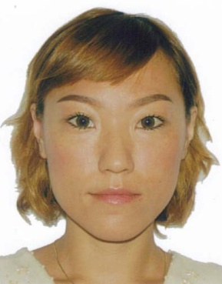

ACADEMIC QUALIFICATION
∙ FEB 2008- Feb 2010 Master of Translation and Interpreting with Master of International
Relations at Macquarie University
∙ Jan 2008 - Aug 2007 TIPP course at Macquarie University
∙ Jan 2007 - May 2007 IELTS class at Queensland Academic Technology in Brisbane
∙ July 2004 – Nov 2004 English intensive course at Tasmania TAFE in Tasmania
∙ Feb 2004 – Mar 1999 Completed Bachelor of Organic Chemistry Dong Duk Women’s University in
Seoul in Korea

PROFESSITONAL EXPERIENCES

∙ Sewoo Education Centre, Sydney November 2010 – December 2011
Executive Administrative Manager
Objectives:
∙ Provided dedicated support to managing director
∙ Supervised employees and monitored their work to ensure all cases are dealt with properly
∙ Participated in training sessions provided by education providers for updated information
∙ Counseled international students about their visa condition and appropriate courses fitting their
circumstance
∙ Addressed and reacted properly to clients issues and concerns
∙ Maintained effective communication with staff e.g. regional advisors and admission officers in
universities and colleges

∙ Market city, Sydney December 2007 – November 2010
Part time shop manager
Objectives:
∙ Developed and managed customer relations to maximize service satisfaction
∙ Monitored and resolved any service issues
∙ Managed scheduling, inventory and proceeded daily store reports along with cash handling
∙ Recruited and trained new employees

∙ Korea, Australia February 2005 - Present
Interpreter / Translator
Objectives:
∙ performed translation of web site preparing for pre-launch of new health product
∙ performed translation of the whole web site of ginseng company in Korea
∙ Performed translation in relation to social affairs through translation auction website from January
2009 to the present
∙ provided an interpretation service for Mission Australia through agency
∙ participated in social work as an interpreter in medical and social welfare settings from January to July 2009
∙performed interpretation as well as translation for Korean company, Korean Ginseng Cooperation,.
February 2005 to November 2006

∙ 2:1 Academy, Seoul January 2007 - December 2007
English teacher
Objectives:
∙ Designed and taught lessons in English for 7th and 8th grade students
∙ Assessed and recorded observations and evaluation of children’s development
∙ Communicated with parents about their children’s activities and provided counseling

∙Hanguk Jinsneg Agricultural Organization, Seoul February 2005 to November 2006
Executive company secretary
Objectives:
∙ Was responsible for all company secretarial functions, duties and responsibilities
∙ Acted as Liaisons between departments, employees and dedicated clients to ensure that issues
requiring attention or problems are properly handled

KEY SKILLS AND COMPETENCIES
∙ Strong organizational and time management skills
∙ Excellent interpersonal and communication skills
∙ Proven leadership
∙ NAATI translation qualification at professional level
∙ Languages: KOREAN proficient
ENGLISH advanced (IELTS conducted Feb: overall 7 including Listening 8.5, Reading
8.5 Speaking 7.0, writing section 7)
∙ Window 98/Me/2000/xp

Reference – Available on Request

