FREELANCE TRANSLATOR CV
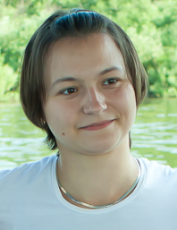

Name: Volkova Ekaterina
Date of birth: 23\04\1988
E-mail: trustno1_05@mail.ru
Work telephone: +79043718191
Address: 650033, Popova st., 1b-103, Kemerovo, Russia.
Nationality: Russia, lived in France (Paris) for 1 year
Work Objectives: fast and efficient translation services, delivery before deadline, always satisfied customers

Mother tongue: Russian
Translation languages: English > Russian, French > Russian
Specialization: Mining, Medicine, Literary translation, General science
Major projects: 2007 – 2008 International Au pair program
2010 Kemerovo Cardiology Center, charitable mission involving US doctors. Interpretation and translation.
2011 Year of the Netherlands in Russia and Year of Russia in the Netherlands. Interpretation.
2012 Thyroid Surgery, PhD work, Russian to French translation.
2013 - 2014 Kuzbass Chamber of Commerce, documents translation.
Computer technology: MS Office, PDF, PhotoShop, Trados, etc.

