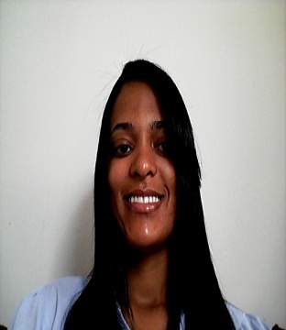

dorcas pereira de j. dos SANTOS
Brazilian, Single, 28 years old – +55(17) 981357559
– e-mail: dorcas624@gmail.com.
Salvador Pitaro street, nº 140 – Coronel Araujo – 15775-000 –
Santa Fé do Sul- SP.

EDUCATION

Law degree by the State University of Mato Grosso do Sul - Paranaiba/MS
Conclusion: December 2011.
LANGUAGE SKILLS
Portuguese as a native language (mother tongue)
Fluent English, skilled at communicating and developing relationship with ESL students and their families. Excellent written and oral communication skills.
Work experience
Experience in teaching and translating English Language.CCAA/CCLS (2007 – 2013)
•Design and teach weekly course for kids, teenagers and adults.
• Meet individually with students to discuss courses, grades, behavior, school applications, and other issues and concerns.
• Maintain contact with parents and guardians of students to develop a network of support and communication around each student.
• Implemented use of new data program in the counseling office to help counselors track student progress

Internship at the Center for Legal Assistance and Practice from the University of Paranaiba-MS, with customer service, development of initials, checking and monitoring of lawsuits (2010 – 2011)

Worked for some months translating a project for a group of members from the Rotary Club – Paranaiba. (2012)

Secretary of a Postgraduate center – providing customer assistance, confectioning certificates, responsible for all Registrar publications, editing, formatting and budgeting, including postgraduate Course Catalog, a full compilation of courses provided by the College.(2009- 2011)

Aditional information

System Operation – Office package
From de 2003 through 2004.

MEC – Mastering English Course by the Cultural Center of Languages Studies
From 2006 through 2008.

Oratory, Course by SEBRAE – Paranaíba-MS.
2009.

Availability for moving to others cities or even country, according to the need of the company.

