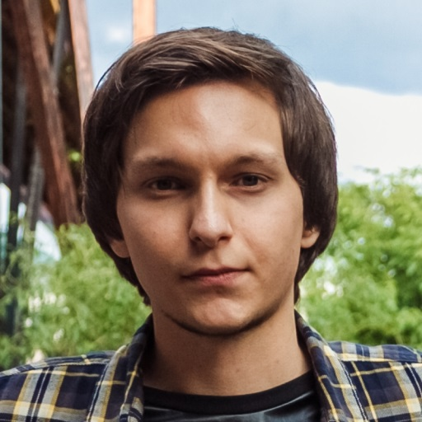
Dmytro Kyrychenko
E-mail: dmitriykirichenko1999@gmail.com
Skype: ticalblunt
City: Kyiv, Ukraine
DOB: 16.02.1993

Higher education:
Kyiv National University of Culture and Arts (September 2010 – June 2015), Kyiv city, Ukraine
Field of study: translation (Master’s degree)
Qualification: Master of translation studies
Proficiency in languages:
English – С2 - Proficient
Russian – native
Ukrainian - native

Working experience:
September 2010 – till now
Freelance narrator/voice over artist/audio engineer performing editing, cleaning, mixing and mastering of various songs, audiobooks, audio tracks for videos, educational programs and many more.
April 2012 – September 2012
Worked under the “Work & Travel” program as a waiter/manager of relations with foreign employees at the “The Old Firehouse” & “Cascada Bar & Grill” restaurants, the city Creede, Colorado, USA.
October 2012 – till now
Freelance translator/interpreter in the city of Kyiv and other places upon request, working on “ProZ”, “Translator’s Café”.
April 2016 – till now
Translator and interpreter at the “Mister Kronos” translation bureau, Kyiv city (languages: English, Russian, Ukrainian). Website: https://mrkronoscompany.com/en/
While working for this translation bureau, I have translated numerous texts of different topics, including medical, legal, official, technical, literary translation for such particular clients as:
- “Boryspil” international airport
- Ukrainian government
- “1+1” TV-channel, Ukraine
- National Palace of Arts "Ukraine" that is located in Kyiv city and for many others.
August 2017 – till now
Online interpreter of English, Russian and Ukrainian languages at the “Trans Gulf Management Consultants” company.
August 2017 – till now
Freelance translator of English, Russian and Ukrainian languages, voice over artist and audio engineer on UpWork. Link to my account with feedback: https://www.upwork.com/freelancers/~01ecbe1edf5df69d2c
Computer skills: active user of Trados software and other translation tools, Microsoft Office, Adobe Acrobat DC, Adobe Audition, Nuendo, Sony Vegas, AutoCAD and many more. Ready to learn how to use other software as well.
I will be glad to do any test task to show my skills, it will be the best way to prove my abilities.

