CURRICULUM VIATE

Surname: SARR 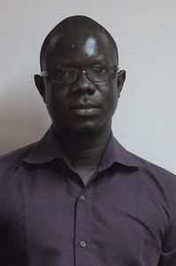
First name: Diégane
English to French Translator
Mobile: +221773162262 / Email: goute105@yahoo.fr
goute105@gmail.com

Professional experience
Freelance translator since 2012: I translate all sorts of documents from English to French.
I have an excellent command of the French language, my native language. English proficiency.
Good knowledge of CAT tools (wordfast, linguee )
Two month-internship at the African Union Commission in Addis Ababa, Ethiopia (September-October 2016)
Two month-internship at African press agency at the translation unit (May-June 2015)
I have strong experience in journalism, writing, proofreading and editing.
Strong experience in communication and marketing: I have been Oxfam America communication consultant in October 2009.
Academic Training
Master of Translation (English-french, French English) (University of Gaston Berger, Saint-Louis)
My linguistic combinations are: French A, English B, Arabic C
Master of Marketing (International school of management of Dakar)
Bachelor of journalism ( Cheikh Anta Diop University)
Bachelor of English arts (Cheikh Anta Diop University)
Local languages
Seereer: native speaker
Wolof: Excellent command
Computer Sciences
Good command of Word, PowerPoint, Excel, outlook,
Good knowledge of CAT Tools (Wordfast, memo Q, linguee, wordrefence, etc))

