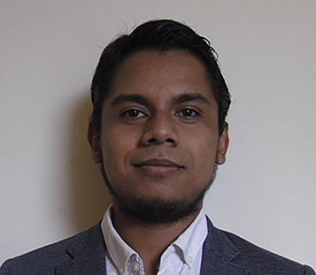MR. DAVID ANGEL DE JESÚS MURO LÓPEZ
Translator
Address: Jiron Triunfo No. 330. Guadalupe, Peru - 13841.
E-mail address: david.muro.lopez@gmail.com
Tel: (+51) 952 835 365
Facebook page: David Angel Muro López
Language pairs: EN|FR|PT(BR) > ES and ES > EN
Availability: eight (8) hours per day and on weekends.
Base rate: 0.05 per word (it might vary, it depends on the text).
Output: 3000 words per day

Personal summary

The ability to communicate and share information through languages is the ulterior reason of my meticulous dedication. I just finished my Bachelor’s degree. I’m desirous to expand and spread my multicultural experience and linguistic knowledge by the results of my work. Proven skilled, talented, and creative translator; I would like to work with a settled and reliable company to elongate reciprocally and responsibly the universe and career of a person, enterprise or organization and myself.

Professional translator and interpreter with four (4) years of experience in health, academic, scientific and technical, development, audiovisual, tourism and literary topics and matters. Also, experienced in proofreading and transcription of audios and videos. I’m committed to meet deadlines and provide high quality products. I’m interested in extending my aptitudes to economic, financial, legal, commercial, and music translation fields.

Work experience

Freelance translator and interpreter | July 2012 – present date
- Translated abstracts of thesis and scientific articles from English into Spanish (vice versa) about many several fields of studies.
- Translated menus of various tourist restaurants in the city where I live in.
- Translated letters of beneficiary families and sponsors for the organization World Vision.
- Interpreted in medical, dentist, eye-care, and audiological campaigns.

Apprenticeship | Aug. 2015 – July 2016
Cesar Vallejo University (Universidad César Vallejo) Translation and Interpreting Services
http://www.ucv.edu.pe/startpage.aspx?nUniOrgCodigo=70000
- Accomplished all translation, interpreting, subtitling, proofreading and transcribing arrangements in English, Spanish, French and Portuguese about diverse issues, such as medicine, engineering, food, birth and marriage certificates, general information, etc.
- Met deadlines.
- Productivity increased significantly during the aforementioned period.

Project supervisor – “Youth Leaders in Action” Program | July 2014 – Dec. 2014
Canada World Youth and Brigada de Voluntarios Bolivarianos del Perú (BVBP)
http://canadaworldyouth.org/
- Served as a language mediator between Canadian and Peruvian participants in order to carry out all the activities they completed, since I was the only polyglot speaker of English, Spanish, and French. Offering bilingual facilitation in a varied spectrum of topics.

Skills and competences

- Intermediate MS Word, MS Excel, MS Power Point, MS Outlook.
- Fluency in Spanish and English.
- Able to understand and express in French and Brazilian Portuguese.
- Developed social skills.
- Fast transcriber.
- Pleasant voice tone.
- Able to work with software for subtitling and video editing.

Education

BA: Translation and Interpreting (top third) | 2010 – 2016
Cesar Vallejo University (Universidad César Vallejo)

Public Management Specialist | 2016
Escuela Nacional de Estudios Gubernamentales

Development Project Management | 2015
Inter-American Development Bank

Interests

Development, music, martial arts and aerobics, TV and cinema, literature, spirituality, coaching.

