“The goal without a plan is just a wish”

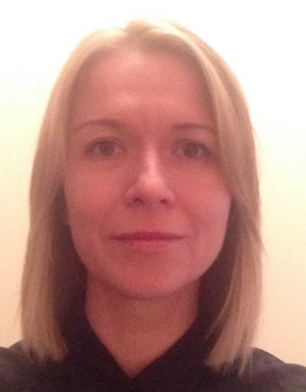
Polyakova Daryna
Date of birth: 16/04/1983
Marital status: married, son
Location: Lviv, Ukraine
E-mail: dpolyakova@gmail.com
Phone: +38 093 9177689

Experience:
Freelance Translator  (Russian/Ukrainian English)  2004 – Present  Main job June 2014-January 2017 (Maternity leave) | Translation for Novyy Channel, Creative Agency (Advertising), KLS, Profpereklad Translation Agency, Smart Business Project, etc.  - Translation of:  *legal documents (agreements, legal opinions, instructions, etc.),  *personal documents (certificates, notarized documents, tax extracts, etc.),  *media marketing materials  *TV bibles, formats  *scripts (+transcribing)  *projects` presentations,  *web-sites,  *videos transcript and translation,  *user guide on On-line Marketing  Main topics: General, Legal, Marketing, Standard documents, TV Industry, Social
Administrative Manager  Waverley Software (IT)  January 2017-present | - Office maintenance (groceries, equipment, design, office supplies, etc.)  - Work with landlord representatives  - Accounting support (bills, Tax Services, budget, reporting)  - Events organization (team-buildings, corporate gifts arrangement, logistics, etc.)  - Business trips support (visa service, tickets, accommodation, transfer, reporting, etc.)  - Cooperation with courier services  - Cooperation with the Head Office in Kharkov  - Settlement of procedures (business trips, teambuilding arrangement)  - Market search for the company needs  - Translation of documentation  - Budgeting (Administration sector)  - Marketing support (cooperation with printing and advertising companies, branded stuff maintenance, cooperation with designers, work according the Company Brand Book, etc.)
PA to General manager/ Executive Assistant  UKRTOWER LLC (Telecommunication)  April 2012 – June 2014 | - Daily support of the General Manager (expat-Turkey): calendar maintenance, meetings arrangement, solving of all the routine matters, including personal (rent apartment, coordination of the house personnel work, language courses, etc.);  - Administrative support of the office operation, including offices in regions (suppliers, landlords, printing companies, mobile operators, leasing, petrol, etc.);  - Translation of documents English/Russian-Ukrainian/English;  - Interpretation on the meetings;  - Business trips arrangement (for all employees –visa support, tickets, accommodation in Ukraine and abroad); For GM-the full scope of business services, including internal reporting documentation);  - Arrangement of the Boards, corporate events;  - Preparation of presentations, reporting documents, minutes for GM;  - Work with state authorities (basic stage) and permitting bodies (permits, medical examination and education for the staff);  - Basic HR duties (announcements, primary and phone interviews, timesheet holding, documentation aspect, etc.);  - Holding of the document flow (basic accounting, full administrative and official document flow, mail registration, internal Orders and Regulations of the Company, etc.);  - Coordination of the General Manager`s orders fulfillment and getting approval from the General Manager;  - Reporting to General Manager and Head Office in Istanbul (budget following; use of the corporate: cars, phones, equipment, travel costs, etc.);  - Participation in budget process (administrative sector).
Administrative Manager  Zeplin Ukraine (kids wear)  January 2011-February 2012 | - Administrative management of the company (work with suppliers, landlords, exhibitions, printing companies, etc.);  - Conclusion of the agreements on administrative and organizational matters, following the procedures according to the agreements` subjects;  - Translation of documents (English/Ukrainian-Russian/English) and interpretation on the meetings;  - Work with travels (visas, tickets, accommodation in Kiev and abroad);  - Holding of the meetings with the perspective partners, counterparts;  - Holding of the document flow of the company;  -Interaction with state authorities (Tax inspection, Fire Inspection, Employment Center, etc.);  - Reporting to the Founder (Turkey).
PA to General Manager/ Executive Assistant  Marks&Spencer Ukraine  November 2007 – November 2010 | - Daily organization and administrative support to the GM (expat- Turkey) including personal requests (such as support of his family in Kyiv, coordination of house personnel work, etc.);  - Administrative office support (suppliers, events, meeting room scheduling, cooperation with the providers of: taxi services, mobile connection, petrol, etc.)  - Translation (mainly legal - agreements, legal opinions), interviews and other materials translation for Mass Media, correspondence and reports translation for GM);  - Interpretation on the meetings;  - Minutes preparing;  - Business trips arrangement for the company employees and foreign colleagues (from Turkey, England) (visa support, tickets, accommodation, transfer arrangement);  - Necessary information search and provision to the GM;  - Coordination of the GM`s orders fulfillment and arrangement of the approvals by GM;  - Close cooperation with all the departments of the Company.
Atlas 2 Project Assistant  UkrSibbank  November 2006- November 2007 | - Administrative support to the Project Manager (expat-France);  - Administrative support to Project Team.
PA Assistant to General Manager  AV-Service LLC  September 2005 – November 2006 | - Administrative Assistance;  - Translation assistance; Interpretation;  - Participation in the Exhibitions abroad and within Ukraine.
Senior Translator  National Television Company of Ukraine  December 2004 – September 2005 | - Eurovision Song Contest 2005 in Kyiv: translation of the full scope of documentation for the Contest, interpretation, accompanying of the international teams, transcribing the texts and programs.

Education:
Kyiv National Academy of Internal Affairs | Degree. Field: Law  Graduation 2013
Kyiv National Linguistics University | Degree. Field: Translator/ Interpreter of English and French  Graduation 2005
Additional information

Computer skills: MS Office – Advanced User, Outlook, Trello, Slack, Mac OS and iOS user, SmartCAT
Typing 170 signs per minute
Languages: Ukrainian/ Russian – native, English – fluent, French and Polish – basic (French was not used after graduation, Polish has been started on Maternity leave).
Interests: traveling, reading, languages and cultures
Social networks: https://www.linkedin.com/in/darina-polyakova-0a19a46/

References may be provided upon request

