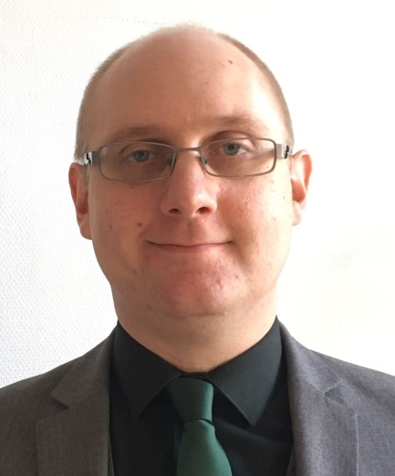
Dan Harris

Address: Rue du Métal 1A,
1060 Saint-Gilles, Brussels
E-Mail: danharristranslations@gmail.com
Website: https://danharristranslationsblog.wordpress.com/

A freelance translator working from French to English. In addition to studying languages, I am a physics graduate with 12 years clinical laboratory experience who combines his scientific experience with his passion for languages in the translation of scientific texts. Other types of texts also translated.

Recent Professional Experience
04/2017 – Present Freelance Translator
Translation of scientific and general texts from French to English. Examples of my work include:
- News articles for the website Watching America.
- Educational videos for the website Sikana.
- Educational material for the organisation EURORDIS, which works on behalf of patients with rare diseases.
04/2011 – 01/2016 National Hospital for Neurology and Neurosurgery, London, UK, Neurometabolic Unit, Medical Technical Officer
Based in a specialist unit for the diagnosis and monitoring of neurometabolic disorders providing an analytical service using a variety of laboratory techniques.
- Provision of highly specialist analytical service.
- Staff training and support to aid the whole team in functioning effectively.
- Development and updating of department procedures to adhere to changing national standards and to improve service quality.
- Liaison with service users including clinicians, patients, and other laboratories to provide the best possible service.

04/2010 - 04/2011 Royal Brompton and Harefield NHS Foundation Trust, London, UK, Biomedical Research Unit, Sample Coordinator
Responsible for obtaining and processing samples for the lung tissue bio-bank.
- Working with patients to explain the hospital’s research programmes and gain informed consent for the storage of samples taken in theatre.
- Liaising with theatre teams to obtain samples from consented patients.
- Administration of bio-bank in compliance with Human Tissue Authority standards.

10/2008 - 04/2010 King’s College Hospital Foundation Trust, London, UK, Blood Sciences Laboratory, Senior Assistant Technical Officer
- Working with other departments and external service users to assist with enquires about or problems with the laboratory service.
- Processing of patient samples for analysis including lone-working at night.

11/2007 – 10/2008 Ashford and St. Peter’s NHS Trust, London, UK, Pathology Department, Pathology Team Leader
- Solving any problems that occur with specimens in liaison with clinical staff.
- Supervision and training of laboratory support staff.

Education
2014-Present BA in Language Studies with French and German (Open University, UK) In progress
1999-2003 BSc in Physics (University of Manchester, UK)
1997-1999 A-Levels in Chemistry (C), General Studies (B), Mathematics (D) and Physics (B) (Crompton House School, Oldham, UK) Baccalaureate equivalent
1995-1997 10 GCSE’s (General Certificate of Secondary Education) at grades A*- B (Crompton House School, Oldham, UK)

Outside Interests

- Amateur singer/songwriter with experience of performing at venues in London and Manchester.
- Volunteer in May 2016 at Queen Mary University of London Festival of Communities.
- Volunteer in June 2016 with ‘Britain Stronger In’, the official organisation which campaigned to keep Britain in the European Union.

