I. Personal Details
Name : Claire lestari anggraini
Address : Pondok Gede estate, block_CD no: 05 Kaliwates Jember – East Java - Indonesia
Phone Number : 0251-000 0000 / 081 000 000 000
Place & Date of Birth : Jember, October 05 1979
Sex : Female
Marital Status : Divorced
Religion : Christianity
Nationality : Indonesia
II. Education Details
1. 1993 Primary School/ SDN Kepatihan V Jember
2. 1995 School / SMP Negeri I Ambulu - Jember
3. 1998 High school/ SMK Negeri 4 Jember
4. 2003 Graduate Finance Administrations Diploma University of Jember
GPA = 2.48 (scale 4)
PREDICATE = Satisfactory

III. Computer Skills
Microsoft Word, Microsoft Excel, Microsoft Power Point, Internet

V. PERSONALITY
Good attitude, kind, communicative, diligent, tolerant, target oriented, discipline, honest, and be responsible

Jember, 2/18/2014

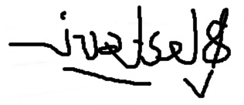
Claire Lestari Anggraini

