First name:  Last name:  Date and place of birth:  Address:  Cell phone:  Nationality:  Family status: | AOUFI  Belkacem  15/03/1975 in OUARGLA; ALGERIA  Rue Gharbouz, Mekhadma, OUARGLA 30.000  +213662270990  Algerian  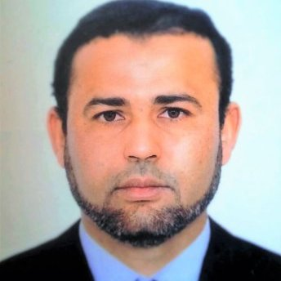  Married
Language ability: | Arabic: very good;  English: very good;  French: very good;
Computer skills: | Microsoft office (word, excel, power point, access, outlook), visual basic, network installation, computer maintenance
Education:
1993 | Baccalaureate in mathematics
1998 | Engineer in Automation, university of Annaba, ALGERIA
2005 | One year of studies to obtain the Safety engineer certificate from ENSPM/IFP in Martigues; France.
2017 | Master in Automation, university of Ouargla, ALGERIA
Training:
1996 | Courses in general English at the «ALGERIAN LANGUAGE CENTER" in Annaba, 6th level.
2004 | Complimentary courses in Instrumentation: (230 hours) at the "IAP". Boumérdes, Algeria.
2006 | - Safeguard competency program by BOOTS & COOTS  - Defensive driving
2007 | TÜV functional safety for engineering professionals program by HIMA in Algiers
2009 | Training in Risk assessment by DNV Energy.
2010 | Training about PHAST software used for Hazard study by DNV Energy.
2015 | NEBOSH, International General Certificate (Credit)
Professional experience:
1999 | Instrumentalist for “BECHTEL” International. INC. in the gas compression station of SONATRACH Rourd Nouss project.
2002 | Senior RIG electrician for “Baker Hughes, INTEQ”. Missions:  • Ensuring maintenance of the rig electrical equipments  • Startup & rig-up
2004 | RIG Instrumentation Engineer for ENTP Drilling Company. Missions:  • Maintenance of rig instrumentation equipments  • Startup the instrumentation equipments for rig-up  • Calibration of measurement equipments.  • Software configuration of rig control system such as mud-watch system
2005 till now | - HSE engineer (Safety and loss prevention) in SONATRACH oil & gas production plant in Hassi Messaoud; ALGERIA.  Mission:  - Ensuring that the company safety and environmental standards and policies are complied.  - Supervision of daily work (maintenance, construction…etc) using the “Permit to Work System” by providing precautions and instructions and making sure that those instructions are complied.  - Supervision of works such as welding, lifting, entering into confined space, Radio Active test, work at height…etc. by inspection, advising, gas test, making sure that energy isolations are realized…etc.  - Provide training and induction for the company personnel and subcontractors  - Training of personnel for firefighting techniques  - Ensure the periodic inspection and maintenance of the fire and gas systems  - Leading of risk assessment studies, such as HAZOP. HAZID, SIL analysis  - Risk analysis (risk assessment)  - Audit and installation inspections  - Carrying out incident and accident investigation and identifying their root causes.  - Prepare safety daily, weekly, monthly and annually reports  - Managing the site safety crew (technicians and inspectors)  - Updating fire fighting procedures  - Maintenance of Fire fighting materials (fixed and mobile)
2012 - 2013 | - Trainer at “Laroui Safety and environmental Solution”.(Rig-pass, Risk assessment, H₂S, Safety supervisor…etc)

