CURRICULUM VITAE
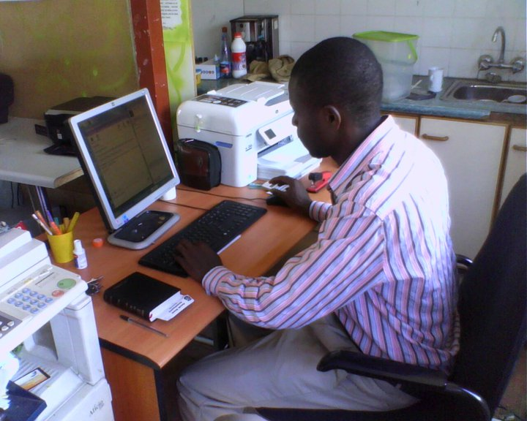

Personal Details
ASOBO TAMBA
Mobile phone: +27734894729
Email: asobisco@yahoo.com
Johannesburg, South Africa
13 GERANIUM STR, ROSETENVILLE

Career’s objective: To provide high-quality language teaching and translation to partners and people

SENIOR FRENCH TRANSLATOR
& TEACHER
(English-French; French-English)

FOUR(04) YEARS OF INTENSE (EXPERIENCE)
Services offered: Translation, language teaching, précis-writing, editing, interpreting, reporting, revision and speech-drafting
Working Knowledge of German

I. Experience in Teaching French and translation
February 2007-2008: Lecturer of French and Translation at the Linguistic Centre (L.C), Graduate School of Translation and Interpretation.
Class level: Actuarial Undergraduate Students.

2008-2009: Part-time teacher of the French Language at C.C.C Mankon, Bamenda, Cameroon
Classes taught: Forms V and IV.

2004-2005: Part-time teacher of the French Language at Longla Comprehensive College,B’da.
Classes taught: Upper sixth and Lower Sixth.

II- Education, qualifications and Training
2004-2006: Bachelor Degree in translation from the Advanced School of translators and Interpreters (ASTI) - University of Yaounde
GPA GRADE: 3.44 on a scale of 4.0
Focus areas: Technical and general translation, reporting, editing, speech-drafting and interpretation.
Minor focus area: Economics
2008-2009: Certificate in IT and computing from P.C Training & Business Institute
Computer Systems & Networking, South Africa
2000-2003: BA in bilingual studies- English and French
University of Yaounde 2.

Major courses: English Language and Literature
French Language and literature,
Translation
Minor course: German
III- Further Training
MARCH 2005: Translator on probation at the Ministry of Public Administration.
Duration: 2 months.
Job description: Translation of administrative and legal documents, Memos, decrees, texts of public interest and speech-drafting Same year: Received training in computer-assisted translation and the use of Internet resources Paul’s Computer Institute.

IV- WORKING EXPERIENCE in Translation

From 2008 to date
Independent consultant with both national and International organizations

2010-to date: Part-time Consultant with the Language Real Deals,South Africa.
Job description: Translation of financial and development-based documents, speech-drafting, translation of course materials and texts based on employment, poverty,Information Technology.
2008-2009: French text translator and Editor with the Friends of Friends Council (A German NGO in Cameroon)
Job description: translation and revision of texts based on Socio-Economic Development

2009-2010: Assistant lecturer of English and translation at the Linguistic Centre (L.C), Graduate School of Translation and Interpretation, Yaounde, Cameroon

V- LEISURE
Reading, Internet & Basketball

I hereby certify that all the information contained in this resume is true to the best of my knowledge and the references listed below could be contacted for verification.

v- REFERENCES
Translation Real Deals, South Africa
Language Coordinator
Contact person: Mpio P.
Contact Number:+27(0)11 434 1175
Email:perez_mpio@yahoo.fr

Iyelbo Consultancy ,USA
Assistant Service HEAD
Fombuh Lesley
Email: fombuhlesley@yahoo.com
Contact: +237 94256091

MeinSchreibservice.de
Roeland Square Unit 14
8001 Cape Town
South Africa
Tel Germany: +49 531 2625-090/-182
Tel South Africa: +27 822 572 025
Email: recruitment@meinschreibservice.de
website: www.meinschreibservice.de

