FREELANCE TRANSLATOR

Arsen Nersisian (age: 33)  Address: Bersha Str. 5/5, apt. 45, Izhevsk, 426068, Russia  Cell phone: +7 963-48-3456-1, QIP: 366261277  Email: nerzig@mail.ru, Skype: arsen_nersisian1983  Position desired: Freelance Translator | 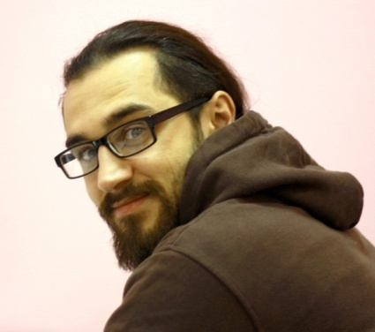
Job objective:
To obtain a position that will allow me working with many languages thus improving my abilities as a translator.

Education:
- HIGHER EDUCATION DIPLOMA
Izhevsk, Russia 2000-2005
Udmurt State University (http://udsu.ru/english/index)
Faculty of Professional Foreign Language
Qualification: Linguist, Translator/Interpreter
Major: Translation and Translation Studies
- ELECTIVE COURSE OF FINNISH
Izhevsk, Russia 2002-2003
Udmurt State University
- PARTICIPATION IN U.S. CAMPOWER PROGRAM (https://www.campamerica.co.uk).
Kansas City, MO, Camp Shawnee, summer 2003

Professional Experience (language related):

Freelance Translator
DIALECT LLC (Translating Agency), Moscow, Russia
2011 - Present
- Translation in the following language pairs: EN→RU, RU→EN, DE→RU, RU→DE, UA→RU, RU→UA, DU→RU, SV→RU, RS→RU, TR→RU, BG→RU, RO→RU, ES→RU, PT→RU, FR→RU, NO→RU, DK→RU, etc.
- Proofreading EN→RU, RU→EN.

Freelance Dictionary Editor
LINGUEE GmbH, Cologne, Germany
March 2016 – till present
- Addition of dictionary entries EN→RU
- Evaluation, correction and writing of examples for the dictionary entries in both English and Russian.

Translator/Interpreter
DIALECT LLC (Translating Agency), Moscow, Russia
2007 - 2011
- Translation in the following language pairs: EN→RU, RU→EN, DE→RU, RU→DE, UA→RU, RU→UA, DU→RU, SV→RU, RS→RU, TR→RU, BG→RU, RO→RU, ES→RU, PT→RU, FR→RU, NO→RU, DK→RU, etc.
- Proofreading EN→RU, RU→EN.
- Interpreting from time to time at the notary’s office.

Computer skills:
Windows, MS Office, CAT tools: MemoQ 2015 and SDL Trados

References:
My profile at https://www.linkedin.com/in/arsen-nersisyan-766858a6?trk
My profile in translators’ community http://www.multitran.com/m.exe?a=116&UserName=nerzig

Hobbies:
Languages, comparative linguistics, geography, travelling, capoeira, books, music

