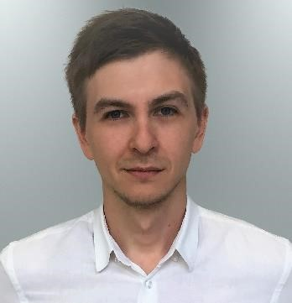
Anton Khairuddinov
Translator of Russian, Ukrainian, English & Spanish

Kyiv, Ukraine | +38 (093) 538-43-78 (Viber, WhatsApp, Telegram) |
e-mail: khairuddinov.antony@gmail.com| Skype: Anton Khairuddinov
Position Desired: Remote Translator (Freelance, written translation):
- English – Russian / Ukrainian
- Russian / Ukrainian – English
- Spanish – Russian / Ukrainian
Previous Experience
- English Tutor 06/2010 — 06/2012;
- Remote Translator (Legal, Medical, Tech (ІТ) documentation) 06/2010 — 06/2012;
- Researcher-translator (Government of Ukraine) 07/2012 — 07/2017;
- Remote Translator (Freelance, written translation) 07/2017 — present time
Education:
- Institute of international relations T.Shevchenko National University of Kyiv 05/2005 — 07/2010;
- Course in English, Regent Cambridge School (Cambridge, UK) 06/2015 — 07/2015.
Skills:
- Fluent in English and Spanish, experienced in written translation and remote work;
- Confident PC, MS Office, Adobe Creative Suite (InDesign, Illustrator, Photoshop, Acrobat Professional), AutoCAD user (almost any software can be acquired and learned quickly); • CAT-Tools: SDL Trados Studio 2017, SmartCat, MemoQ, Deja Vu;
- Professional web search.
Soft Skills:
- Punctual, responsible;
- I am well-organized in my daily tasks and comply with timeframes;
- I consider myself to be a good team player as well as team leader;
- Always in touch (by quickly online responding to requests).
Customers, End Clients and Documents:
- Tech/IT: PJSC Turbogaz, PJSC Lukoil (Oil and gas production and processing documentation, operational and maintenance documentation, etc.); Cisco, Bosch, Bayer (localization of user interface, user manual translation, software localization, product descriptions);
- Legal: PJSC Rosneft Oil Company, LLC RN-Purneftegaz, OTIS, Servier, GlaxoSmithKline (Agreements and Contracts, Certificates, Statutes, Permissions, Regulatory Docs, Acts, Regulations, Decisions, Laws, Instructions etc.).
- Medical/Pharmacology: CRO: PPD, IQVIA (QuintilesIMS), INC Research (Medical Trial Documentation,
Study Documentation, Informed Consent, Drug Documentation, Patient Health Assessment Form, Certificate, Clinical Protocols, Regulatory Documents etc.);
- Other - marketing: BrabensAdvisor, ZinCo (Agreements and Contracts, Insertion Orders, etc.) Finance, Banking: PRAVEX BANK (Risk Management, Methodological Guidelines, Credit Risk Appetite Limits etc.), Cryptosphere (Business Plans, Articles, Analyses, Token Sales Agreement, Whitepaper etc.).

