Curriculum Vitae

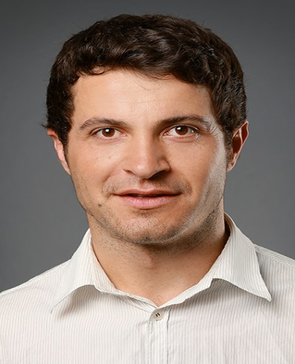
Personal Information

Name: Anton Georgiev Hristov
Birth: March 23, 1980
Born in: Haskovo/ Bulgaria
Email Adress: anton_georg2002@yahoo.com
Telephone: +49(0)15738827191
Address: Rathenower Str. 26, 10559 Berlin/Germany

Education  School  - Hll. Kyril and Method School (primary education)- Malevo/Bulgaria  - Secondary Vocational School in Construction and Architecture “Nikola Fichev”- Pleven/Bulgaria  Specialty: Construction and Architecture  University  - University of Varna/Bachelor Degree  Specialties: Business Economics/ Management/ Tourism Management  - University of Potsdam/Bachelor Degree  Specialties: Political Sciences/Public Administration/German Language and Literature  Languages  - German  - English  - Bulgarian  - Russian  - Serbian/Croatian  - Macedonian | Experiences  - Translator (English- German- Bulgarian)- Freelancer  - Freelance Teacher in German for Foreigners  - Translator and Order Processing Manager (Elada AD; Working Location- Rotterdam/ Netherlands)  - Applications Assessment and Interviewing Applicants at the United Office for Medical Labor Recruitment- Working Languages; German, Bulgarian, English (Berlin/Germany)  - Training at the Berliner Institute for Foreign Languages and Cultures  - Training in Intercultural Understanding, German and English Languages at Studienkollege of Potsdam (Potsdam/Germany)  - Robert Bosh Foundation- Department of Foreign Aid for East European Developing Countries-Working on The Project “Democracy in Ex Yugoslavian Regions” (Berlin/Germany)  - Event Manager at “Gala Catering” (Berlin/Germany)

