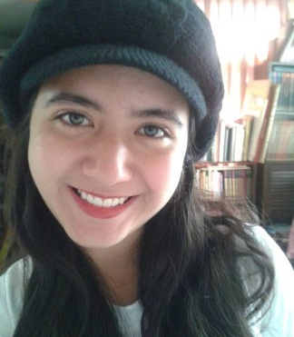
Andrea González Briseño

Personal Information

Address: Morelia, Michoacán, México
Cellphone: +52 443 528 43 13
E-mail: andrea.traducciones@hotmail.com
andrea.gb@alphax.mx
Website: https://andreatraducciones.wixsite.com/traducciones
Facebook: https://www.facebook.com/AndreaTraducciones
LinkedIn: linkedin.com/in/andrea-gonzález-briseño-014a8a117

Professional Profile

I am a Computer Systems Engineer, currently working as a web developer and freelance translator. I offer adaptability, organization, creativity and flexibility, among other aptitudes.

I have experience subtitling series and movies for IYUNO Media Group and Amara On Demand. I also work as translator for Amazon and I have done independent translation work. I have experience developing websites for Alpha X Web Development. I guarantee excellent quality in my work.

Professional Experience

2017 – Alpha X Web Development
Websites development, mobile apps, ecommerce.

2017 – Amazon
Translating products.

2017 – Amara On Demand
Subtitling videos on YouTube.

2017 – IYUNO Media Group
Subtitling movies and series. Translation of titles and description for movies and chapters.

2017 – Freelance Translator
Translating texts, mainly articles. Proofreading and spelling correction.

2012 – 2017 – CH.K.T ESTO
Collaborator of local magazine CH.K.T ESTO, proofreading and spelling correction.

Education

College:
Instituto Tecnológico de Morelia (ITM) Computer Systems Engineering specialized in Web Technologies (2012 – 2017)

Languages (English)
- Colegio Salesiano Lumena, Zitácuaro, Mich. Basic (2000 – 2009)
- Summer course, Planetario de Morelia “Lic. Felipe Rivera”. Basic (2005)
- PREFECO Melchor Ocampo, Zitácuaro, Michoacán. Intermediate (2009 – 2012)
- Students’ English Conversation Club, Zitácuaro, Mich. Intermediate (2009 – 2012)
- Instituto Tecnológico de Morelia, Morelia, Michoacán. Grammar and Conversation I and II (2013 – 2014)

Computing
- Programming languages: Java, HTML, CSS, PHP, JS
- Frameworks such as Laravel, Codeigniter
- Text editors and Word processors
- Editing photos with Photoshop
- Trados (CAT tool)
- MateCat (CAT tool)

References

Erándeni Zúñiga Hernández
Students’ English Conversation Club Professor
Phone: +52 715 104 17 42
e-mail: sweetlovegacor@hotmail.com

Beatriz Briseño Correa
CH.K.T ESTO magazine Manager
Phone: +52 715 110 00 75
e-mail: betandy2000@hotmail.com

