Anastas Pushkarov
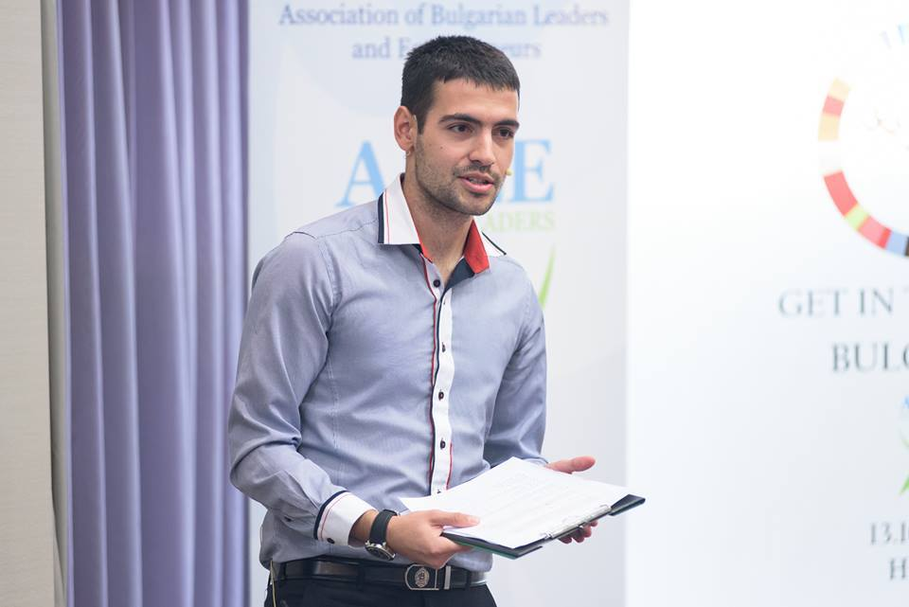
PERSONAL DETAILS

ADDRESS Ivan Rilski Str.50 , Plovdiv
EMAIL agp110@aubg.bg nasko_pushkarov@mail.bg

TELEPHONE +359 887 587470
GENDER Male
NATIONALITY Bulgarian
AGE 22
WORK EXPERIENCE
October 2012- now I have worked part time on translations from English to Bulgarian and Bulgarian to English in StartUP@Blagoevgrad and Radio AURA, as well as in a number of courses related to entrepreneurship, business and finance.
November 2014-now I have worked part time on marketing and sales of an air purifier Airfree. This experience helped me improve presentational and idea creation skills.
October 2014 I hosted the National Final of Get in the Ring Startup competition in Hotel Hilton, Sofia. I practiced my public speaking and facilitating skills in front of more than 150 business and entrepreneurship oriented individuals. This further improved my leadership and networking skills.
September 20- October 10, 2014- I organized and hosted an entrepreneurship workshop in Blagoevgrad. I found sponsors, launched a marketing campaign and facilitated an event which consisted of presentation and practice of the separate steps in the entrepreneurship process. I gathered and analyzed the feedback I received from the 30 participants.

July 10, 2014- August 16, 2014 I participated in the Summer Entrepreneurship Program in the USA (organized by the Institute of International Education and funded by America for Bulgaria Foundation), which took place in New York, Boston and San Francisco. I studied entrepreneurship for 3 weeks in Babson College and cofounded a startup called ARTery (an online platform for art). I learned and practiced the process of developing a startup, improved my leadership and team work skills, learned how to reach and speak to customers, and gained more insight into American culture and values, corporate, educational and entrepreneurial environment.
June 1, 2014 – July 8, 2014 I was an intern in Societe Generale Expressbank, observed and participated in the activity of both corporate and individual clients departments. I gained a good understanding about the products and services the bank offers: credit instruments, deposits, cashiers operations, cards and accounts. My tasks involved cold calling (promoting new products), preparing and inspecting customer files, making inquiries on clients and providing consulting to clients. I successfully applied my theoretical knowledge and communication skills to almost all of the front end operations of the bank.
August 26, 2013- now I have been a member of StartUP@Blagoevgrad club in AUBG in lectors department. There I worked also as a translator- I had to create bilingual descriptions of the lectors (in Bulgarian and English). In the process of approaching and speaking to successful entrepreneurs and businessmen, I learned a lot about the essential elements of a business. I hosted the conference in mid-March, which gave me the opportunity to improve my public speaking and leadership skills, my creative thinking and improvisation under pressure.
August 27, 2012- now I have been a member of Radio Aura’s sales team. My duty is to look for sponsors and partners, promote the club, and organize events and parties. This position develops my salesperson and marketing skills, communication skills and leadership.
May 20-August 20, 2013 I participated in the Work & Travel Program at Provincetown, MA in the USA. I worked heavily at two jobs: cashier in the Portuguese Bakery and waiter, busser and runner in the Seafood Grille, Waterford Inn Restaurant. These jobs increased drastically my performance under pressure and my ability to handle conflicts arising with a diverse mixture of people. I significantly enhanced my customer service skills.
June 1- August 31, 2012 I increased my participation in Beach Volleyball events to five in the National League (Smolyan, Pomorie, Sofia, Plovdiv, and Varna) and even took part in the European Beach Volleyball Championship (Varna). I confirmed my knowledge and skills from last year and was even assigned first and second referee at the National Matches. As a result I acquired higher sense of leadership and responsibility on top of the hardworking skills I had already built.
June 1- August 31, 2011 I took part in 3 Tournaments of the National Beach Volleyball League of Tournaments (Pomorie, Sofia, Varna) and in 1 CEV Challenger Beach Volleyball Tournament (Varna). I served as an organizational assistant, scorer and line judge. These events gave me an experience in team working, improved my concentration and organization, also stamina and endurance under heavy conditions (high temperatures and humidity, working time over 14 hours per day).
PROJECTS
- Entrepreneurship Projects : ARTery /Online Platform that multiplies and centrally manages artists’ content through a number of art shops/
- Entrepreneurship Projects : Playnow.Bg /Online Reservation and Management System of Soccer Fields and Amateur Leagues/
- Corporate Finance Project: Financial evaluation of Yahoo, Google and AOL.
- Management Informational Systems: Online HR Platform for linking graduating students with prospective employers

SKILLS/ATTRIBUTES

- Social skills:
- Reliability
- Organizational skills
- Leadership
- Responsibility
- Time Management
- Critical Thinking
- Creative Thinking
- Teamwork
- Languages:
- English – perfectly spoken and written
- German – spoken (low level)
- Bulgarian – mother language
- Official certificate for mastering basic bartender and waiter skills received after a two-week special course and passed examination.

- Computer skills:
- Good knowledge of MS Office
- Visual Basic
- HTML
- JMulti
- STATA

EDUCATION
September 2011 - Present: American University in Bulgaria
COURSE OF STUDY: Economics and Business Administration Majors
Informational Systems Minor (In Progress)

September 2006 – June 2011: American College of Sofia (Bulgaria)
QUALIFICATIONS: High School Diploma
ACHIEVEMENTS
Presidents List Award for the first three semesters for a GPA over 3.90 out of 4 in the American University in Bulgaria (AUBG).
‘Summa Cum Laude’ academic title in the American College of Sofia (Top Five Graduates)
The Sports Award in the American College of Sofia based on:
-one second place and two 3rd places in the Sofia City Table Tennis tournament (two years as a captain), two times intramural champion of the school.
- Two years captain of the Volleyball Team with two first places and one third place in Sofia tournaments.
-Participation in Soccer High School Team.
-Two-time champion of AUBG Olympics in Table Tennis and Volleyball.

INTERESTS
- Sports (Soccer, Volleyball, Table Tennis, Tennis, Skiing, Snooker)
- Reading and Writing ( mainly poetry)
- Finance Theory and Trading (FOREX, NASDAQ)
- Entrepreneurship
- Hiking and tourism
- Playing Guitar

