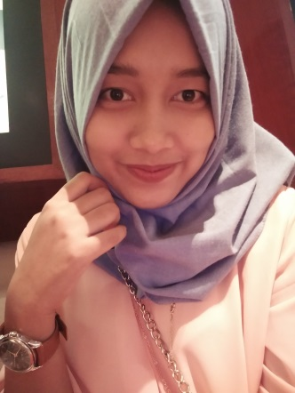
Amanda Alifia
Email : amandaalifia1103@gmail.com Phone : +6282218426595
Address: Rumah Kos Banjar Pelangi, Dusun Sukawening,
Desa Hegarmanah RT 04/RW 06
Kecamatan Jatinangor, Sumedang
West Java 45363
Indonesia

Objective

Highly motivated and hardworking undergraduate student from Department of English, Universitas Padjadjaran, seeking to apply my abilities to the position of translator.

Work Experience
Penelitian Hibah Kompetitif FIB Universitas April 2015 — June 2015

Padjadjaran 2015

Field Assistant in Research

Research Title: Resistensi, Negosiasi dan Kritik Kultural: Membaca Narasi Reflektif atas Nilai Lokal dalam Pendidikan Perempuan

14th Globelisc International Conference October 2016

Liasion Officer

Qualifications

- Born and raise as Indonesian native speaker with adequate knowledge of Indonesian culture and audiences
- Experienced with providing translation service (English to Indonesian, vice versa) to fellow students from any majors
- Proficient in Microsoft Office, Google Drive and other software tools for translation purpose
- Enthusiastic in learning new knowledge related to translation to obtain required results
- Dedicated to finish given tasks on scheduled time
- Able to prioritise work
- Highly oriented to details
- Well-organized

Education

English Studies September 2012 — February 2017

Universitas Padjadjaran

Interests
- Reading: Reading is a necessary activity to gain further insights, especially for given courses at the university. In addition to required reading materials from lecturers, I enjoy reading novels at leisure, especially modern ones. My favorite novel is "Welcome to the World, Baby Girl" by Fannie Flagg.
- Music: I also enjoy listening to music from local singers to foreign ones. I usually listen to pop, soul, rock, R&B, and, sometimes, hip hop music. Once or twice in a month, my friends and I go to karaoke to release our stress by singing out loud (although our voices are far from harmonious).
- Watching movies and TV shows that use English: I find this activity incredibly helpful to improve my English skill. I practice my listening ability by trying to find out what speakers say on screen. Aside from reading, this also helps me to enrich my vocabularies and knowledge, particularly in American expressions. Therefore, I provide a couple of hours every weekend to watch, usually with companion of friends.
- Snail-mailing: I joined a snail-mail group in social media recently to exchange letters via mail from new friends all around the world. I truly enjoy this activity because it allows me to get to know people from different cultures and countries. The hardship to write letters by handwriting, to decorate them later to become attractive ones, and then to receive the long-awaited reply, give a certain satisfaction that I cannot get from popular chatting applications.

Transcript of Records
Subjects | Credits | Duration | Classes | Grade in Figure | Grade in Letter
Translating General English Texts | 2 | 50 | 16 | 76 | B
Translating General Indonesian Texts | 2 | 50 | 16 | 77.8 | B
Translating Specific English Texts | 2 | 50 | 16 | 71 | B
Translating Specific Indonesian Texts | 2 | 50 | 16 | 75.5 | B
Translating Scientific English Texts | 2 | 50 | 16 | 80 | A
Translating Scientific Indonesian Texts | 2 | 50 | 16 | 80 | A
Translation Studies | 2 | 50 | 16 | 75 | B
Interpreting | 2 | 50 | 16 | 75 | B

