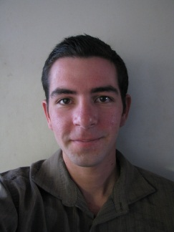
Alfredo Alarcon
2-17-1 Negishi, Taito-ku, Tokyo 110-0003
alfredoalarcon87@hotmail.com
November 7th, 1987
- February 2011 - November 2011: Bar tender at Pig & Whistle Historic Pub in Rotorua, Bay of Plenty, New Zealand.
- February 2011 – November 2011: Cleaning and Reception at Blarney’s Rock Backpackers in Rotorua, Bay of Plenty, New Zealand.
- November 2009 – August 2010: Spanish- English and English-Spanish translator of technical documents and business correspondence at Cristacurva – High Technology Glass in Zapopan, Jalisco, Mexico.
- October 2008 – November 2009: Travel agent, sales, and customer service representative over the phone for American companies at Hispanic Teleservices in Guadalajara, Jalisco, Mexico.
- April 2004 – September 2008: Cook and delivery driver at Pepperoni’s Pizza in Sugar Land, Texas, USA.
- February 2003 – September 2008: Volunteer construction worker and roof supervisor for Habitat for Humanity in Houston, Texas, USA.
- September 2004 – June 2006: Volunteer in set crew and set construction for theatre in Clements High School, Sugar Land, Texas, USA.
- January 2006 – January 2007: Installation of home theatre systems and speakers for Best of All: Custom Home Theatres in Houston, Texas, USA.
Special skills:
- TEFL course with TEFL International, Tokyo.
- Completed advanced first aid course with Red Cross New Zealand.
- 100% fluency in English and Spanish.
- Beginner Italian, French, and Japanese.
- Quick and enthusiastic learner.
- Social and friendly.
- Flexible and adaptable to any hours or work setting.
- Patient, hardworking, and responsible.

