CURRICULAM VITAE
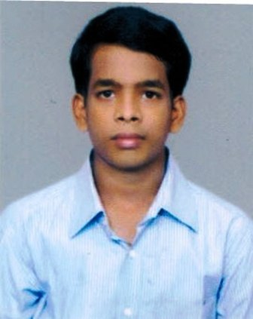
Aditya Prasad Dakua
Lanjipalli, keshab nagar 2nd line,
Berhampur, odisha
Phone : +91 9438071034
Email : adityaprasad939@gmail.com

Professional Summary :
To associate with esteemed organization and work for the betterment of the Organization & myself

CURRENT EXPERIENCE:
1 year & 5 Months experience in HP on order management.
2 year as a freelancer for translation in indian languages.

Skill Summary:

- End to end process Domain expert certified with excellence
- Experience in working in SAP R3, order management tool for different clients
- Recognized as a good team player
- Good at building and managing customer relationship, an excellent team player with excellent communication skills and team management capabilities

Other Work/Task:

- Creating sale order report, development reports and supporting documentation
- Chat with client to solve issue
- Task Distribution to other team members
- Mail Forwarding and Reply Client Mail
- Send the mail to client for the status of works

Additional Skill Summary:

- End user Creation, Deletion and Password resetting.
- Configuration Template, Softkey Template.

Educational Profile:

Course | Institution | Board Of Study / University | Year of completion | %  Obtained
B.B.A | Presidency college | Berhampur university | 2012 | 72
+2 | Berhampur University | CHSC-Odisha | 2009 | 50
10th | Municipal corporation high school | HSC-odisha | 2007 | 69

Personal Information:

- Name : Aditya Prasad Dakua
- Fathers Name : Rajendra Dakua
- Mothers Name : Sibani Dakua
- Date of birth : 09/03/1992
- Nationality : Indian
- Sex : Male
- Marital Statu : Single
- Languages known : English, Hindi & odiya

Declaration:

I do here by declare that all the above mentioned statement or facts are true and correct to the best of my knowledge and belief.

Place : Berhampur Aditya Prasad Dakua
Date :

