RESUME
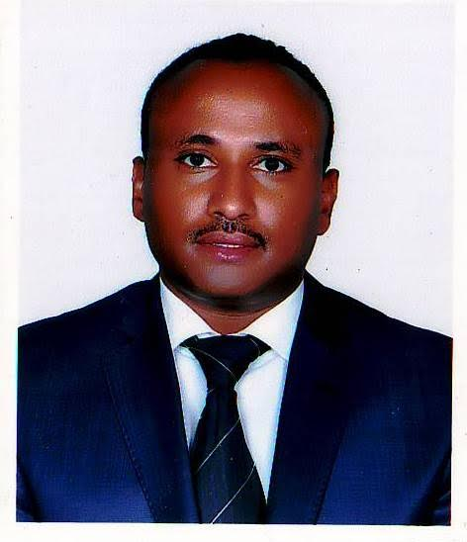
Name: Abraham Moshe Gebre  Address;- KolfeKeraniyo Sub City  District 10,Addis Ababa,Ethiopia  Ethiopian National  Mother tongue :- AMHARIC | Telephone : +251-111-56-45-72  Mobile: +251-91-141-85-87  P.o.Box:- 28968 Addis Ababa  E-mail: ethiomoshe@yahoo.com  Ethiotrans1@gmail.com

I.OBJECTIVE
To obtain a freelance Translation, Interpretation, Transcription and Typing jobs for the Ethiopian Languages (AMHARIC,OROMO AND TIGRYINYA)

II.LANGUAGE PAIRS
English–Amharic English-Oromo English-Tigrinya French-Amharic Arabic-Amharic
Amharic –English Oromo-English Tigrinya-English Amharic-French Amharic-Arabic

III.ACADEMIC BACKGROUND:
- Master Degree in Documentary Linguistics, Addis Ababa University, Ethiopia, 2013
- Master Degree in Social Psychology, Addis Ababa University, Ethiopia, 2015
- Bachelor of Arts in Linguistics, Addis Ababa University, Ethiopia, 2001
- Diploma in Computer Application, Addis Ababa, 2003
- Certificate in French ,Alliance Ethio-Francaise,Addis Ababa,2005
- Certificate in Arabic, KsBethel Language Training Center,2008
- Certificate in Chinese, English Zone School, Addis Ababa, 2013
IV. LINGUISTIC SKILLS
- Ethiopian Language (Amharic, Oromo and Tigrinya)Translation, Interpretation,subtitling, Transcription, Typing
- Proofreading & Editing, and Harmonization,
- Teaching English as a foreign Language and Teaching Amharic for Foreigners

I have been rendering Translation, Interpretation, and Transcription service for several Agencies and Companies. I have got a wide experience in journalistic, tourist and medical translations. Translation of legal text (notarial texts, fines), training manuals, instructions manuals, questionnaires, business proposals, and some other small translations (product descriptions, personal and commercial correspondence…), among others.

V.AREA OF EXPERTISE
- Social Sciences,Linguistics,Education, Psychology, Medical, Legal, Finance, and Agriculture,
VI.SOFTWARE SKILL
- Microsoft Office 2007/10
Microsoft-Word, Microsoft-Excel and Microsoft Access
AdobePhotoshop, PowerPoint,
VII.LANGUAGE
- Amharic-Mother tongue Arabic-Good
- English-Excellent/Fluent Chinese-Good
- French-Good
VIII.EXPERINCE
- Ten years (2006-2016)
X.MAJOR PROJECTS
- Children Adoption Documents for Balbalika International Adoption Agency (Spanish Agency based in Addis Ababa, Ethiopia) 2009-2014
- Proceedings preparation for Christian Relief Development Association- 2010
- Documentary film and promotional document translation for Gebeyanu Business Promotion and Communication 2010-2015
XI.CONFERENCES
- 5th Faculty of Languages and Linguistics Postgraduate Research Conference, Addis Ababa University, Nov. 2014, Addis Ababa. Presenter
XII.MEMBERSHIP
- Member of the African Linguists and Translators -2012
XIII.PROFESSIONAL CERTIFICATION
- Certified Professional Translator, Document Authentication and Registration Office, Addis Ababa, 2007
XIIII.PROFESSIONAL VIRTUES
- Honest,Reliable,Meet deadlines,Initiative and Flexible
REFERENCES
- SelamKedir-Former Deputy-Director of Balbalika International Adoption Agency
Telephone +251911 33 06 09 Email:- selam12@gmail.com
- BerhanuAtref-Current Director of Balbalika International Adoption Agency
Telephone +251911 16 32 64 Email:-birhanuatref@gmail.com
- SemuKetema:-Program Coordinator for Christian Relief Development Association
+251923 11 91 69/+251911 82 69 67 Email semu@crdaethiopia.org
- Solomon Shumye-Managing Director of Gebeyanu Business Promotion and Communication
Telephone +2519224741 Email gebeyanu@yahoo.com

